Lesson | Activity Outline | Knowledge and Skills | Context
1 | LO: To create a class page in the floorbook  Before starting the lesson, assess students' prior knowledge by discussing:  - What a floorbook is and its purpose.  - The importance of working together as a class.  - The significance of listening to and respecting others' ideas.  Starter: Introduces the concept of a floorbook and its purpose. Start a discussion on the benefits of working as a team and respecting each other's contributions. Display examples of class pages from previous years to inspire creativity.  Input: Explain the task: Students will work in small groups to create a class page to promote everyone in the class. Model active listening and effective communication during the explanation.    Plenary: Marvellous Me ‘Activity’  Floorbook expectation: QR codes, pupil voice, videos, and images. | L1. about what rules are, why they are needed, and why different rules are needed for different situations | This lesson plan aligns with the 2014 National Curriculum in England, specifically focusing on Personal, Social, Health and Economic (PSHE) Education. The lesson objective is to create a class page in the floorbook, which encompasses elements of collaboration, creativity, and communication, essential skills within the PSHE curriculum. This activity also promotes teamwork, self-expression, and respect for others' opinions, all of which are integral to the PSHE curriculum.
2 | LO: What is ‘mental health’?  Evaluation of Prior Knowledge:  To assess prior knowledge, the teacher can start by asking students what they think mental health means. This can be done through a class discussion or a short writing task. Understanding the baseline knowledge will help in tailoring the lesson to suit the students' needs.  Starter: Begin the lesson by asking students to share what they think mental health means. Discuss as a class and write down keywords on the board. Introduce the topic of mental health and explain that mental health is about how we think, feel, and behave.  Input: Show a child-friendly video or presentation that explains mental health in simple terms. Define key terms such as 'mental health', 'emotions', 'well-being', and 'stress'. Discuss different emotions and how they can affect our mental health.  Activity: Divide the class into small groups and provide each group with a scenario related to mental health (e.g., feeling anxious before a test). Ask students to discuss how they would feel in that situation and what they could do to improve their mental health. Encourage creative thinking and problem-solving.  Plenary: Bring the class back together and have each group share their scenarios and solutions. Summarise the key points about mental health discussed during the lesson. Encourage students to ask any remaining questions they may have.  Plenary: Marvellous Me ‘Activity’  - Floorbook expectation: QR codes, pupil voice, videos, and images. | H15. that mental health, just like physical health, is part of daily life; the importance of taking care of mental health | This lesson plan is aligned with the 2014 National Curriculum in England for PSHE for Year 3 and Year 4 students. The focus is on understanding the concept of mental health, which is part of the statutory requirements in the PSHE curriculum.
3 | LO: Why is it important to look after mental health?  Evaluation of Prior Knowledge: Start the lesson by asking students what they know about feelings, emotions, and mental health. Discuss any previous learning on emotions and mental health. This will help gauge students' prior knowledge and provide a starting point for the lesson.  Starter: Begin with a short mindfulness exercise to set a calm and focused tone for the lesson. Show students images of different emotions (happy, sad, angry, etc.) and ask them to describe what they see and how those emotions might feel.  Input: Define mental health and explain that it is as important as physical health. Discuss different emotions and how they can affect mental health. Talk about ways to look after mental health, such as talking to someone, being active, getting enough sleep, and taking time to relax.  Activity: Divide the class into groups and provide scenarios where a fictional character is facing a mental health challenge. Ask each group to come up with ways to help the character and support their mental health. Alternatively, you could have a class discussion where students share different ways they can look after their mental health.  Plenary: Gather the class back together and ask each group to present their ideas on how to support the fictional character's mental health. Summarise key points about the importance of looking after mental health from the discussions.  Plenary: Marvellous Me ‘Activity’  Floorbook expectation: QR codes, pupil voice, videos, and images. | H15. that mental health, just like physical health, is part of daily life; the importance of taking care of mental health | The lesson plan is aligned with the 2014 National Curriculum in England for Personal, Social, Health and Economic (PSHE) Education for Year 3 and Year 4. The lesson focuses on the importance of looking after mental health, which ties into the curriculum's aim of promoting mental and emotional wellbeing.
4 | LO: To have a varied vocabulary when talking about feelings  Starter: Begin with a feelings matching game where students match pictures of facial expressions with corresponding emotions. Discuss in pairs what they think each emotion might feel like.  Input: Introduce new vocabulary related to feelings: e.g., joyful, frustrated, scared, content, etc. Provide definitions and examples for each new word (also use Widget). Encourage students to repeat after you to practice pronunciation.  Activity: Divide the class into small groups. Provide a scenario for each group where they have to discuss how a character in the situation might be feeling. Encourage them to use the new vocabulary learnt. Each group presents their scenario and discusses the emotions involved.  Plenary: Gather the class together and discuss the different emotions explored. Ask students to share which new word they found most interesting and why. Review key vocabulary and reinforce their meanings.  Plenary: Marvellous Me ‘Activity’  Floorbook expectation: QR codes, pupil voice, videos, and images. | H19. a varied vocabulary to use when talking about feelings; about how to express feelings in different ways; | The lesson plan aligns with the 2014 National Curriculum in England objective for Year 3 and Year 4 students to have a varied vocabulary when talking about feelings. This supports the Personal, Social, Health and Economic (PSHE) Education curriculum, focusing on emotional literacy and communication skills development.
5 | LO: To learn strategies to respond to feelings  Starter: Begin the lesson by discussing with students what emotions are and why it is important to recognise and manage them. Use examples of different scenarios to highlight the impact of emotions on behaviour.  Input: Introduce key vocabulary:  Emotions: Feelings such as happiness, sadness, anger, fear, etc.  Managing emotions: Actions taken to control and respond to different feelings.  Discuss with students the importance of recognising their own feelings and those of others. Provide examples of intense or conflicting feelings and how they can be expressed. Teach strategies for managing feelings appropriately, such as deep breathing, speaking to a trusted adult, or taking a break.  Activity: Divide students into small groups and provide them with scenarios involving different emotions. Ask each group to discuss how they would feel in that situation and come up with appropriate ways to respond to those feelings. Encourage students to share their ideas with the class and discuss the effectiveness of different strategies.  Plenary: Gather the students back together and recap the lesson by asking them to share one strategy they learned for managing their feelings. Discuss the importance of using these strategies in real-life situations.  Plenary: Marvellous Me ‘Activity’  Floorbook expectation: QR codes, pupil voice, videos, and images. | H20. strategies to respond to feelings, including intense or conflicting feelings; how to manage and respond to feelings appropriately and proportionately in different situations | This lesson plan aligns with the 2014 National Curriculum in England for Personal, Social, Health and Economic (PSHE) Education. The objective is to develop students' strategies to respond to and manage their feelings appropriately and proportionately in different situations.
6 | LO: How do I cope with change and loss?  Starter: Begin the lesson by showing pictures of different scenarios that represent change and loss.  Ask students to share what they think is happening in the pictures and how the people might be feeling.  Discuss as a class.  Input: Define key terms: change, loss, grief, and bereavement. Explain how change and loss can impact feelings using age-appropriate examples. Introduce healthy ways to express feelings such as talking to someone, drawing, or writing.  Activity: Divide the class into small groups and provide scenarios related to change and loss.  Ask each group to discuss how the person in the scenario might be feeling and come up with ways to help them manage their feelings. Each group presents their ideas to the class.  Plenary: Recap the key points discussed during the lesson. Ask students to share one thing they learned about managing grief and loss.  Plenary: Marvellous Me ‘Activity’  Floorbook expectation: QR codes, pupil voice, videos, and images. | H23. about change and loss, including death, and how these can affect feelings; ways of expressing and managing grief and bereavement
7 | Assessment: Create a poster about mental health. E.gs:  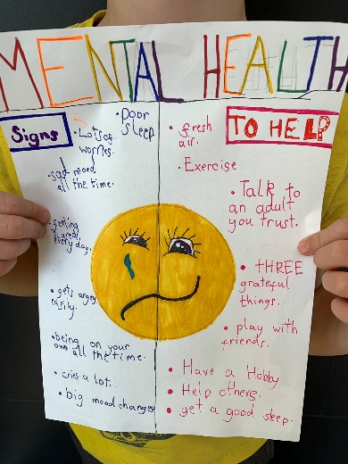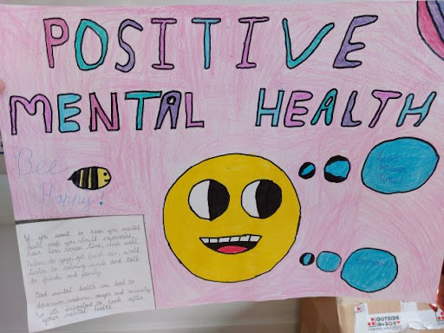 | As above

