Geography. Medium Term Planning
Term: Autumn 1 | Year: 5 and 6 | Theme: Maps and Fieldwork

National Curriculum | Week | Skills taught | Knowledge | Activity Outline | Key vocab
Pupils should extend their knowledge and understanding beyond the local area to include the United Kingdom and Europe, North and South America. This will include the location and characteristics of a range of the world’s most significant human and physical features. They should develop their use of geographical knowledge, understanding and skills to enhance their locational and place knowledge. Pupils should be taught to: Locational knowledge  ♣ locate the world’s countries, using maps to focus on Europe (including the location of Russia) and North and South America, concentrating on their environmental regions, key physical and human characteristics, countries, and major cities  ♣ name and locate counties and cities of the United Kingdom, geographical regions and their identifying human and physical characteristics, key topographical features (including hills, mountains, coasts and rivers), and land-use patterns; and understand how some of these aspects have changed over time  ♣ identify the position and significance of latitude, longitude, Equator, Northern Hemisphere, Southern Hemisphere, the Tropics of Cancer and Capricorn, Arctic and Antarctic Circle, the Prime/Greenwich Meridian and time zones (including day and night)  Place knowledge  ♣ understand geographical similarities and differences through the study of human and physical geography of a region of the United Kingdom, a region in a European country, and a region within North or South America  Human and physical geography  ♣ describe and understand key aspects of:  ♣ physical geography, including: climate zones, biomes and vegetation belts, rivers, mountains, volcanoes and earthquakes, and the water cycle  ♣ human geography, including: types of settlement and land use, economic activity including trade links, and the distribution of natural resources including energy, food, minerals and water  Geographical skills and fieldwork  ♣ use maps, atlases, globes and digital/computer mapping to locate countries and describe features studied  ♣ use the eight points of a compass, four and six-figure grid references, symbols and key (including the use of Ordnance Survey maps) to build their knowledge of the United Kingdom and the wider world  ♣ use fieldwork to observe, measure, record and present the human and physical features in the local area using a range of methods, including sketch maps, plans and graphs, and digital technologies. | 1 |  |  | Assessment of map skills.  Putting out different types of maps such as:  Globes, atlases, ordnance survey of the local area and digital maps. Children list the features they can identify such as:  - Longitude and latitude  - Keys  - What symbols they can identify  - Scale (what type of scale is used)  - Compass  - Grid reference- What type 2 -6  - Can they identify the northern and southern hemisphere on a world map?  - What climate zones can they spot?  Then they can identify how each feature makes it a good map and explain why these features are essential on a map. | Scale, linear, accurate, biomes,
 | 2 | Children use fieldwork to observe, measure, record and present human features using a range of methods, including sketch maps, plans and graphs, and digital technologies |  | To use geographical skills to follow clues.  Take digital photos of features in the grounds from odd angles or very close up. Print them off with a map which will include grid references give children the photos and they identify where the place/object is on the map using grid references and compasses for direction. Pupils must find the location of the photos, then take their own photos and create clues to help others find their objects/place on the map. | 8 compass points, cardinal points,  intercardinal
 | 3 |  |  | To use scales on a map to locate objects and places.  Saved on the SharePoint is a scales activity based around London. Explain to children that a scale is a large object scaled down and the scale shown on the map if for accuracy. Children glue the map in their books and use the scale provided to answer the questions. | Scale, linear, direction, accuracy,
 | 4 | Children develop their understanding of recognising and identifying key physical and human geographical features of the world; how these are interdependent and how they bring about spatial variation and change over time.  Children will become confident in collecting, analysing, and communicating a range of data. Children can explain how the Earth’s features at different scales are shaped, interconnected and change over time. |  | To use contour patterns to identify change over time.  Introduce contour lines and explain that these are used to measure the height of land. The closer they are the steeper the slop.  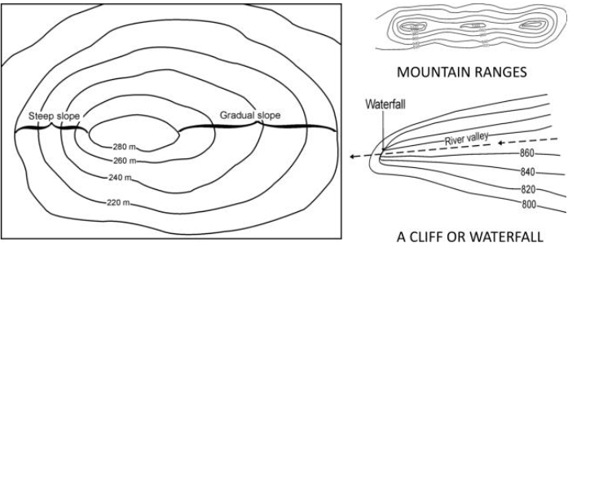  Contours, keys and symbols - BBC Bitesize useful video to show them.  Use a map of the lake district (attached below) and compare them to a map of Walsall town centre. Discuss the contour lines and other features they should already know such as  - Land use  - Amenities  - Roads  - Human and physical features. | Contour, slop, steep
 | 5 | Children can use the eight points of a compass, four and six-figure grid references, symbols and key (including the use of Ordnance Survey maps) to build their knowledge of the United Kingdom and the wider world. |  | To collect and analyse data.  Children to go out locally (permission is needed) Identify the different types of land use that is local to use- houses, shops, roads, fields etc. Discuss whether we are a hamlet, village, town or a city and ask them to explain how they know this. Collect the data and analyse the land use. What do we have more of why? This can be shown in a scatter graph or a bar chart.  Keep this information and take photos as you go for use in the next lesson. | Data, analyse,
 | 6 | Children can use the eight points of a compass, four and six-figure grid references, symbols and key (including the use of Ordnance Survey maps) to build their knowledge of the United Kingdom and the wider world. |  | To create a detailed sketch map.  Using a small area can children create their own sketch map from school to the local park or shopping centre. They need to include key feature such as  - Compass  - Bar scale (extra challenge)  - Key to include land use.  - Human and physical features identified with symbols.  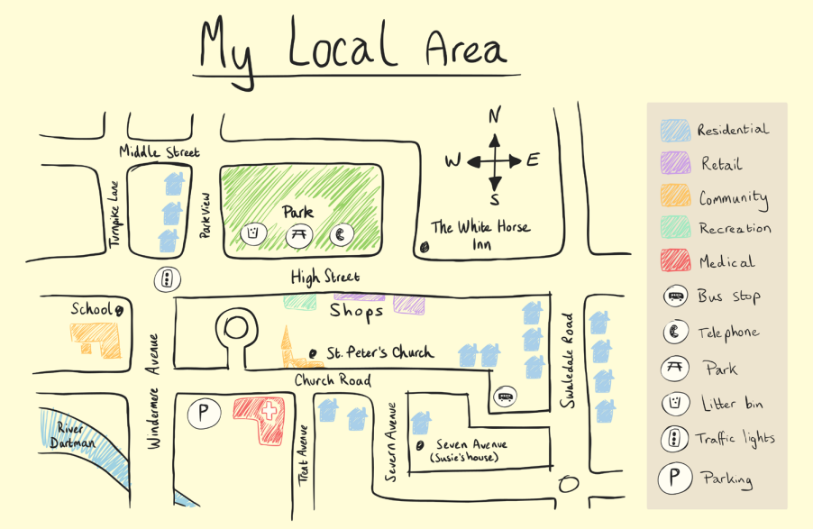
 |  |  |  | Assessment lesson

