Computing Medium Term Planning Cycle B
Term: Autumn 2 | Year: 4/5 | Topic/Unit: 4.2 Online Safety and 4.11 Micro:bits
Key Vocabulary
Lesson 1- Report, SMART rules, spam, attachment, phishing, digital footprint
Lesson 2- Malware, software, virus, AdFly, ransomware, cookies
Lesson 3-Plagiarism, watermark, citation, copyright, collaborate
Lesson 4- Data analysis, collaborative database
Lesson 5- Accelerometer, data, sensor, variable

Lesson 6- Infinite loop, logic, light sensor, variable
Lesson 7- Conditionals, gestures, selection, simulation, variable
Evidence: Please can all class teachers generate an example of work that is Working towards, Working at and Working to GD for each unit and upload them to the computing curriculum folder (or email to Kathryn) for monitoring. Evidence is collected for Computing Folder in SLT room.
National Curriculum | Week | NC Coverage | Skills taught | Knowledge | Activity Outline
• To understand how children can protect themselves from online identity theft.  • To understand that information put online leaves a digital footprint or trail and that this can aid identity theft.  • To identify the risks and benefits of installing software including apps.  • To understand that copying the work of others and presenting it as their own is called 'plagiarism' and to consider the consequences of plagiarism.  • To identify appropriate behaviour when participating or contributing to collaborative online projects for learning.  • To identify the positive and negative influences of technology on health and the environment.  • To understand the importance of balancing game and screen time with other parts of their lives.  • Understand how sensor inputs from the accelerometer can be used to detect movement, such as when a step is taken.  • Understand that variables are used to keep track of the current step count.  • Apply this learning to build a practical, real-world project.  • Understand how inputs, outputs, and computer code work together to make control systems.  • Understand how logic (conditional ‘IF/ELSE’ instructions) is used to make different outputs happen depending on changes in data from a sensor.  • Use ‘repeat forever’ infinite loops to keep control systems responding to changes in the environment.  • Use the accelerometer via the ‘when gesture: shake’ block to start the code running.  • Make use of logical ‘IF’ conditional instructions.  • Apply these concepts to make a computer simulation of a real-world game.  • Use the accelerometer via the ‘when gesture: shake’ command to start the code running.  • Make use of more complex logical ‘IF’ conditional instructions.  • Apply these concepts to make a computer simulation of a real-world tool. | 1  Unit 4:2  Lesson 1  Going Phishing | Understand how children can protect themselves from online identify theft.  Understand that information put online can leave a digital footprint that can lead to identity theft. | To know what a security symbol is.  To know the meaning of ‘phishing’ and be aware of scam websites.  To understand what identity theft is. | • Children know that security symbols such as a padlock protect their identity online.  • Children know the meaning of the term ‘phishing’ and are aware of the existence of scam websites.  • Children can explain what a digital footprint is and how it relates to identity theft.  • Children can give examples of things that they would not want to be in their digital footprint. | Preparation:  The activity Spam is an Email simulation of SPAM messages. Currently, at the end of each message is a line that says ‘*Email Simulation 2Respond activity’. You can make this activity more realistic by editing the simulation to remove this reference. See the 2Email Guide to find out how to edit 2Respond simulations and set it as a 2Do. When setting it as a 2Do, use the following title and description in the 2Do: Title = Email Practice, Description = Let’s revise what you know about 2Email.  SMART rules displayed in the classroom or as screensavers or backgrounds on devices. Resources to do this can be found in the Teacher area in Online Safety Resources.    Digital connections 2Connect file, save a copy of this file in the class folder and enable collaboration by clicking on this button ->  (Optional) set the 2Respond activity: Confidential Information as a 2Do.  You can select the following objectives when setting a 2Do to make future assessment easier  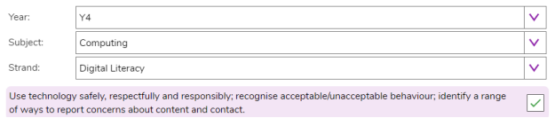  Lesson:  Outline the lesson aims, success criteria and vocabulary. Revisit the vocabulary at the end of the lesson to review with the children.  Activity 1: Email  Use slide 5 to direct the activity. Once children have opened this, tell them you must sort something out for a few minutes, while you are doing this, they should check any mails that they have and respond to them if necessary. The text of the first message is:  Dear Customer,  You have been selected to enter our prize draw. You are a guaranteed winner.  Please press reply and type in ‘winner’  Bob - Global Email Company.  Observe how children react to the message, some will report the message, and some will reply to everything. The details of the rest of the simulation follow: The slide shows what happens if children click the report to teacher button; show this to children after they have had a chance to complete the activity.  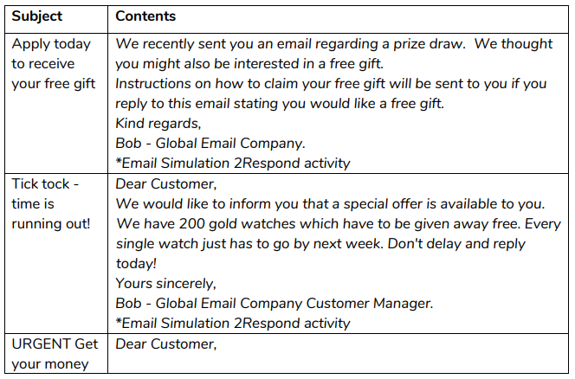  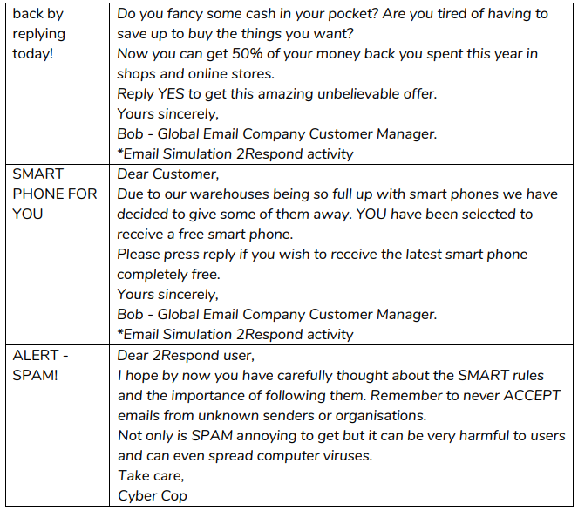  Activity 2: SMART Rules  Use slide 6. Direct children to the resources they will need. Clicking will display the rules on the slide and some questions and answers.  Spam Emails in Detail:  Use slides 7-10 to examine the spam emails in more detail. Slides 11-13 move to emails in external mail systems. If you have them, replace the images on slide 10 with some of your own.  Activity 3: Digital Footprints  Slide 14 relates to digital footprints, if the class have followed the scheme, they will have learnt about this in year 2. If they need a reminder then you can use the quiz from the year 2 unit Digital Footprint Quiz. By clicking on the icon. Go through the questions together  Plenary:  Review meaning of vocabulary and the success criteria. Children could rate how well they achieved this using a show of hand.
 | 2  Unit 4.2  Lesson 2  Beware Malware | To identify the risks and benefits of installing software including apps. | • To identify possible risks of installing free and paid for software.  • To know what malware is.  • To know what a computer virus is. | • Children can identify possible risks of installing free and paid for software.  • Children know that malware is software that is specifically designed to disrupt, damage, or gain access to a computer.  • Children know what a computer virus is. | Preparation:  Set the 2Respond activity ‘Downloading Software’ as a 2Do for your class, as in the previous session, change the name of the activity to ‘Waremal Virus Update’ and the description to ‘Email installation practice’.  • Set the Online Safety Top Tips as a 2Do for the class. You can select the following objectives when setting a 2Do to make future assessment easier:  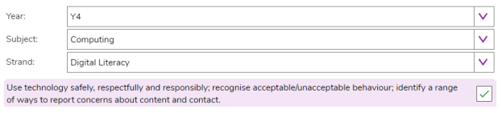  Discuss new vocabulary with the children on vocab slide.  Go through PM slides.  Activity 1: Downloading Software  Use slide 6. Ask children to complete the 2Respond activity. After having done 2Respond tasks last week, they are likely to work out that this is a simulation. Ask them to use the activity to give you some information about what installing something could do to a device. These are the emails in the Downloading Software thread:  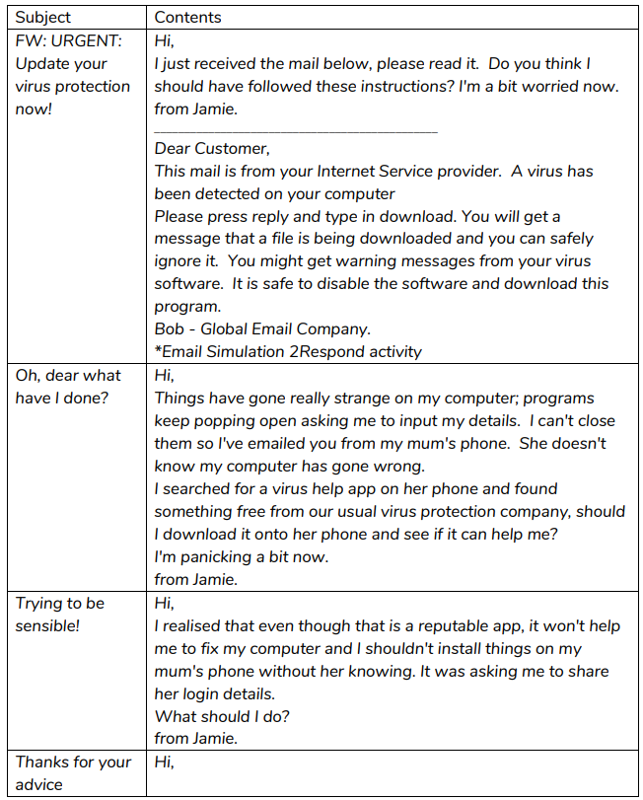  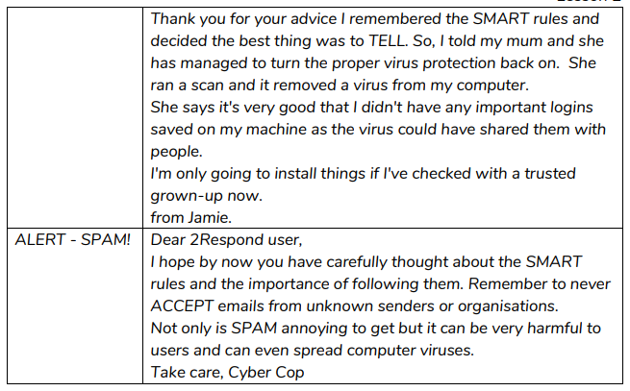  Malware, Downloading and Viruses:  Use slides 7-13. Clicking reveals further points for discussion. On slide 11 discuss the WannaCry virus; you might be able to find a video about the effects of this online. Discuss the impact of such an attack; it could mean a life-or-death situation to patients.  Activity 2: Online Safety Tips  Use slide 14. You could ask children to hand in the file, mark it and set it as a redo for children to refine next lesson.  Plenary:  Review meaning of vocabulary and the success criteria from slide 3. Children could rate how well they achieved this using a show of hands.
 | 3  Unit 4.2  Lesson 3  Plagiarism | • To understand that copying the work of others and presenting it as their own is called 'plagiarism' and to consider the consequences of plagiarism.  • To identify appropriate behaviour when participating or contributing to collaborative online projects for learning. | To identify which activities can infringe another’s copyright.  To understand what plagiarism is. | • Children can determine whether activities that they undertake online, infringe another’s copyright.  • Children know the difference between researching and using information and copying it.  • Children know about citing sources that they have used. | Preparation:  • Completed Writing Template about Tim Berners Lee. This file contains two pages, the first is plagiarised, the second is not. This will be used as a whiteboard resource.  • Access to Wikipedia.  • Plagiarism Quiz  • Print the Screen-Time Record Card. Each child will need a copy (each sheet has two record cards and can be cut in half), this is to hand out at the end of the session for children to complete over the week in preparation for the next lesson. You can select the following objectives when setting a 2Do to make future assessment easier:  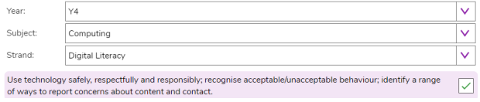  Discuss new vocabulary with the children on vocab slide.  Go through PM slides.  Activity 1: Investigating Plagiarism  Use slides 5 - 8 and Purple Mash itself as a class on the whiteboard. Click to reveal points for discussion.  Activity 2: Plagiarism Quiz  Use slide 9 to direct the activity.  Activity 3: Home Study  Use slide 10. Hand out the record-cards to be completed for the next lesson (ideally in a weeks’ time). Discuss how to fill in the cards. Children should record how much time they spend on screen, which device and what they were doing as well as off-screen activities that they do.  Plenary:  Review meaning of vocabulary (click on words to reveal the definitions)
 | 4  Unit 4.2  Lesson 4  Healthy Screen-time | • To identify the positive and negative influences of technology on health and the environment.  • To understand the importance of balancing game and screen time with other parts of their lives | Identify positive and negative influences of technology.  Find a balance between being active and digital activities.  Give reasons for limiting screen time. | • Children can take more informed ownership of the way that they choose to use their free time. They recognise a need to find a balance between being active and digital activities.  • Children can give reasons for limiting screen time. | Preparation:  • Completed record cards handed out in the end of the last session.  • Screen-Time 2Investigate Database – open this and use the ‘Share’ option in the menu to set this a 2Do before the lesson, with collaboration switched on – see notes in activities.  • Screen Time Study writing frame to be set as a 2Do.  Lesson:  Discuss new vocabulary with the children on vocab slide.  Go through PM slides.  Activity 1: Home Study  Use slide 5, you might have to show children how to calculate average hours of sleep per night. The slide asks children to consider their personal screen-time, privately. Stress that this is not an exercise in embarrassing anyone or a competition.  Screen-Time Database  Use slide 6-7. Recap what a database is and explain to children that they will be creating a class database to investigate their screen time. Use the database design to explain how the data will be collected.  NB: You will need to have set the Screen Time Database as a collaborative 2Do before the lesson – instructions to do this are as follows: Open the Screen Time Database and click on ‘Launch’:  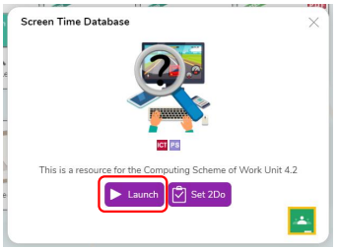  Click on the menu and select ‘share’:  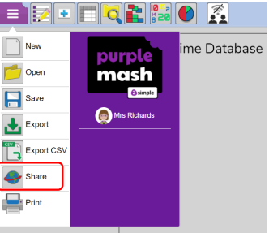  Save the file to your work folder – give it a name and click on ‘Save’:  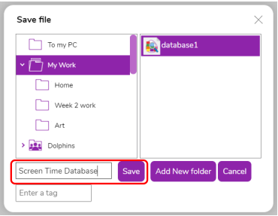  Click on ‘Set as 2Do’:  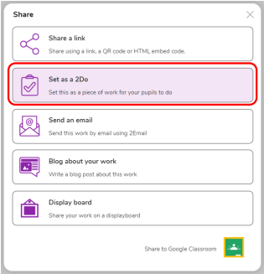  Enter the title and description, make sure you tick ‘Work collaboratively’ and then complete setting the 2Do:  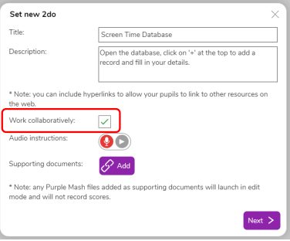  Activity 2: Entering Data  Use slide 8 to guide children. Open the database on the screen by clicking ‘Preview’ in your 2Dos. The children will open it by clicking on ‘Start’ in their 2Dos.  Activity 3: Data Analysis  Use slides 9-11 to guide children in creating and saving graphs and then analysing what they show.  Activity 4: Extension  Use slide 12 to open a link to the writing frame. Talk through it and then ask children to open it from their 2Dos and complete it. Explain how to upload the graph image if necessary.  Plenary:  Review meaning of vocabulary and the success criteria from slide 3. Children could rate how well they achieved this using a show of hands.
 | 5  Unit 4.11  Lesson 1  Step Counter | • Understand how sensor inputs from the accelerometer can be used to detect movement, such as when a step is taken.  • Understand that variables are used to keep track of the current step count.  • Apply this learning to build a practical, real-world project | Understand that variables are containers for storing data.  Able to use the accelerometer and variables to turn a micro:bit into a step counter.  Apply your learning to build a practical, real-world project. | • Children can turn a micro:bit into a step counter using the accelerometer and variables.  • Children can explain that accelerometer is a sensor, an input that senses movement.  • Children can explain that variables are containers for storing data which can be accessed and updated. | Preparation:  Unless otherwise stated, all resources can be found in the Lesson 1 folder on the main unit 4.11 page. From here, click on the icon to set a resource as a 2Do for your class.  Free Code micro bit link to activity to set:  Purple Mash by 2Simple  Set Lesson 1 Step Counter (in the resources area) as a 2Do. You can select the following objectives when setting the 2Dos to make future assessment easier:  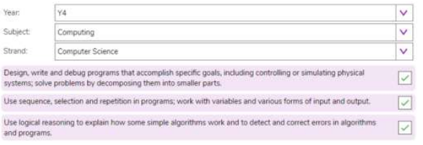  Lesson 1:  Discuss new vocabulary with the children on vocab slide.  Go through PM slides.  Think: Starter Actvitiy:  What is a Micro:bit?  ▪ A tiny computer  ▪ You tell it what to do by writing instructions in code.  ▪ The code is an algorithm, a sequence of instructions.  ▪ The micro:bit can show words (and numbers and pictures) on its LED display output.  ▪ LEDs are light emitting diodes, the lights on the front of the micro:bit. Information sent out of a computer is called an output.  ▪ You can unplug your micro:bit, attach a battery pack and the code still works. If children have completed the 4 lessons in Unit 3.10, this slide will be revision of what they already know about micro:bits.  Slide 7: Introducing the accelerator:  Watch this video to find out what the micro:bits built-in accelerometer does and how it can be used as an input device we can program.  Explain that the accelerometer is a sensor input that senses when you shake your micro:bit.  Children may have already used accelerometers to count steps using phones, watches or fitness trackers.  The accelerometer is labelled on the back of the micro:bit, so you can see where it is – even though it’s tiny, it contains moving parts that react to movement.  Optionally play video: https://mbit.io/lessons-accel-video  Slide 8: Step Counter Introduction Video  Watch the video which introduces the step counter project which children will be programming in Free Code Micro:bit. Optionally play video: https://youtu.be/GB0ucZsGVfA  Slide 9: Create: Examine the Code  Read through the code and see if children can predict what will happen in the simulator when the program is run.  Explain:  At the start, the code sets a variable called ‘steps’ to 0. The ‘steps’ variable keeps track of how many steps we’ve taken.  When the accelerometer input senses a shake, the ‘steps add 1’ command adds 1 to the number stored in the ‘steps’ variable.  After the ‘steps’ variable is updated, ‘display text’ displays the new count on the LED display output.  Variables help us count how many steps we’ve taken. They are containers for storing data which can be accessed and updated while a program is running.  It’s a good idea to set variables to a known value at the start of a computer program. The order of blocks is important – the code must show the ‘steps’ variable number on the LED display after it’s been updated, or the count will be out-of-date!  Slide 10: Create: Build the Code  Watch the video on how to build the code then follow the link to open Free Code micro:bit and model building the code yourself. Optionally show the class the video on YouTube: https://youtu.be/VLkBkxbA25k  Slide 11:  Run your program using the simulator to test your code before connecting to the micro:bit. If you need to debug your code (make changes to the code so that it runs as you want it to), do this and run the code again in the simulator.  Slide 12:  Now that you have built your program and tested it in the simulator, you’re ready to transfer it so that it will run on a real micro:bit. Watch the video on how to connect a micro:bit to your computer to transfer and run the code or follow the instructions on the next slide. Optionally play video: https://youtu.be/326nC2tfcH4  Follow the instructions on slide 13 of how to connect a micro:bit to your computer to transfer and run the code.  Slide 14:  Children open Free code Micro:bit which has been set as a 2Do in preparation for the lesson and complete the code. Children transfer code to their micro:bit and test. If you have a battery pack, encourage children to unplug micro:bits from computers and attach batteries. Their code remains on the micro:bit and will still work. To test the program as a step counter, the micro:bit and battery pack could be attached to a leg using a strap.  Slide 15:  Children can discuss their code with a talk partner: Questions: Does it work as you expect?  ▪ If not, do you need to debug the code and download it again?  How good is the project?  ▪ Can you think of anyone who would like this project and find it useful of enjoyable?  ▪ How could you improve it?  ▪ Children may find the display hard to read, that they have to stamp their legs to record steps, or that it counts fewer steps than they expected. See ‘Extend’ below for some ideas for improving the project.  ▪ Could it have other uses?  ▪ How does it work?  ▪ Encourage children to think about how it works when using it.  Slide 16: (Optional)  If children finish early, they can modify their code to make it more accurate.  Discuss:  • Is it only counting one leg?  • How could you program your step counter more accurately to count both legs? If the step counter is attached to one leg, it may be counting the movement of just one leg rather than steps with both legs. Children could compensate for this by modifying the code and adding 2 to the step count each time.  • Add blocks to show the step count when you press button A this means you can read the step count at any time without having to shake the micro:bit.  Plenary:  Review meaning of vocabulary and reflect on success criteria.
 | 6  Unit 4.11  Lesson 2  Night Light | • Understand how inputs, outputs, and computer code work together to make control systems.  • Understand how logic (conditional ‘IF/ELSE’ instructions) is used to make different outputs happen depending on changes in data from a sensor.  • Use ‘repeat forever’ infinite loops to keep control systems responding to changes in the environment. | Understand how inputs, outputs and computer code works.  Able to code a micro:bit to make a light.  Identify that sensors are inputs. | • Children can code a micro:bit to make a light that switches on when it gets dark using sensors and logic.  • Children can explain that sensors are inputs that sense things in the real world, such as movement and light.  • Children can explain that logic is how computers make decisions in code based on whether things are true or false. | Preparation:  • Free Code Night Light Activity link to activity to set as 2Do  • Lesson 2 whole class teaching slides  • Student handout (optional) – LED planning sheet  • Set Free Code micro:bit (in the resources area) as a 2Do. You can select the following objectives when setting the 2Dos to make future assessment easier:  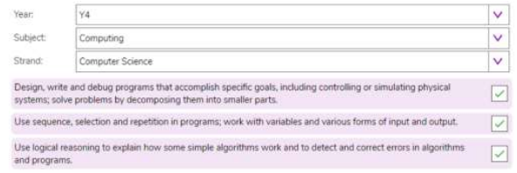  Lesson:  Go through PM slides, introducing vocabulary. Recap prior learning on slide 5.  Slide 6: Watch the video which explains: The micro:bit’s LEDs, as well as acting as an output, the micro:bit can also work as an input, sensing how dark or light it is. We can use this to make projects that react when it gets dark or light. Optionally show the light sensor introduction YouTube video: https://mbit.io/lessons-light-video  Slide 7: Watch the short video which introduces the night light project. This explains that the micro:bit light sensor works in a range from 0 (very dark) to 255 (the brightest it can go). Optionally play the project introduction video: https://youtu.be/QqwWK3oJGDM  Slide 8: Read through the code and see if children can predict what will happen in the simulator when the program is run. Explain: The ‘repeat forever’ loop keeps the micro:bit checking the light level. The logic ‘IF/ELSE’ block checks if the light level is low, less than (<) 100.  Else the light level must be 100 or more. It must be light, so it turns the LEDs off with ‘clear screen’.  Slide 9: Watch the video on how to build the night light code then follow the link to open Free Code micro:bit and model building the code yourself. Optionally play video: https://youtu.be/VBb1p4D7DJs  Slide 10: Run your program using the simulator to test your code before connecting to the micro:bit. If you need to debug your code (make changes to the code so that it runs as you want it to), do this and run the code again in the simulator.  Slide 11: Now that you have built your program and tested it in the simulator, you’re ready to transfer it so that it will run on a real micro:bit. Watch the video on how to connect a micro:bit to your computer to transfer and run the code or follow the instructions on the next slide. Optionally play video: https://youtu.be/326nC2tfcH4  Slide 12: Follow the instructions to demonstrate how to connect a micro:bit to your computer to transfer and run the code.  Slide 13: Children open Free code micro:bit which has been set as a 2Do in preparation for the lesson and complete the code. Children recreate the code in Free Code micro:bit, testing it in the simulator. Children transfer code to their micro:bit and test. They can cover and uncover the micro:bit, shine a light on it, move it closer and further away from a light source, or cover it with different materials. If you have a battery pack, encourage children to unplug micro:bits from computers and attach batteries. Their code remains on the micro:bit and will still work.  Slide 14: Children can discuss their code with a talk partner:  Questions:  Does it work as you expect?  ▪ Change the number 100 to a smaller number if the LEDs switch on too easily.  ▪ Change the number 100 to a larger number if it’s hard to make them switch on.  ▪ Transfer the code to the micro:bit and test again. How good is the project?  ▪ Would you recommend it to a friend?  ▪ How could you improve it?  ▪ Could it have other uses?  ▪ How does it work?  ▪ Encourage children to think about how it works when holding it in their hands  Plenary:  Review meaning of vocabulary (click on words to reveal the definitions)
 | 7  Unit 4:11  Lesson 3  Rock, Paper, Scissors | • Use the accelerometer via the ‘when gesture: shake’ block to start the code running.  • Make use of logical ‘IF’ conditional instructions.  • Apply these concepts to make a computer simulation of a real-world game. | Be able to code a game using inputs, random numbers, variables and logic.  Be able to make a computer simulation of a real-world game. | • Children can code a micro:bit rock, paper, scissors game using inputs, random numbers, variables and logic.  • Children can explain how combining inputs, random numbers, variables and logic can make a computer simulation of a real-world game | Preparation  • Free Code rock, paper, scissors Activity link to activity to set as 2Do  • Lesson 3 whole class teaching slides  • Student handout (optional) – LED planning sheet  • Set Free Code micro:bit (in the resources area) as a 2Do. You can select the following objectives when setting the 2Dos to make future assessment easier:  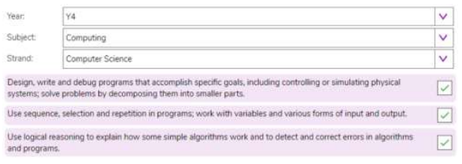  Lesson:  Slide 2 & 3: Outline the lesson aims and success criteria. Ask:  • What is an input?  • What input would be useful to use in this game? (The accelerometer is a good input to use because it can sense when we shake the micro:bit which fits the game.)  • What are random numbers? (Talk about examples like dice. Is a dice more random than a human playing rock, paper, scissors? Do your children think a computer will be truly random?)  • What are variables? (We used variables in the step counter project to keep track of our steps. Today we’re going to use them so we can test a random number and show different pictures depending on its value.)  • What is logic? (We used logic in the nightlight project to turn the light on if it was dark. Here we’ll use logic in the form of IF commands to make different pictures appear to represent rock, paper, or scissors depending on the random number generated by the micro:bit.)  • A simulation is a computer version, or model, of something in the real world. The MakeCode editor has a simulator of a real micro:bit, for example.  Review vocabulary on slide 4.  Slide 5: Ask your children what they discovered last time, for example:  ▪ Last time we coded our micro:bits to make a light that switches on when it gets dark using sensors and logic.  ▪ Today we’re going to use the accelerometer sensor and even more logic to make a micro:bit simulation of a wellknown game. A simulation is a computer version, or model, of something in.  Slide 6: Watch the short video which introduces the rock, paper, scissors project, explains how to play the game and which icons will be used: https://mbit.io/lessons-rock-intro-video  Slide 7: Read through the code and see if children can predict what will happen in the simulator when the program is run.  Explain:  The accelerometer sensor input triggers the ‘when gesture: shake’ command.  A random number between 1 and 3 is stored in a variable called ‘randomnumber’  The logic ‘IF’ block tests the value of the variable.  If the number is 1, it shows a rock icon.  If the number is 2, it shows a paper icon.  If the number is 3, it shows a scissors icon  Slide 8: Watch the video on how to build the rock, paper, scissors code. You can click on the link to open Free Code micro:bit and model building the code yourself. Optionally play video: https://youtu.be/UyglHP0_pnM  Slide 9: Run your program using the simulator to test your code before connecting to the micro:bit. If you need to debug your code (make changes to the code so that it runs as you want it to), do this and run the code again in the simulator.  Slide 10: Now that you have built your program and tested it in the simulator, you’re ready to transfer it so that it will run on a real micro:bit. Watch the video on how to connect a micro:bit to your computer to transfer and run the code or follow the instructions on the next slide. Optionally play video: https://youtu.be/326nC2tfcH4  Slide 11: Follow the instructions to demonstrate how to connect a micro:bit to your computer to transfer and run the code.  Slide 12: Children open Free code micro:bit which has been set as a 2Do in preparation for the lesson and complete the code. Children recreate the code in Free Code micro:bit, testing it in the simulator. Children transfer code to their micro:bit and test. If you have a battery pack, encourage children to unplug micro:bits from computers and attach batteries. Their code remains on the micro:bit and will still work.  Slide 13: Children can discuss their code with a talk partner:  Questions:  ▪ Does it work as you expect?  ▪ If not, do you need to debug the code and download it again?  ▪ How good is the project?  ▪ Do you think the micro:bit is a fair opponent?  ▪ Is it a good simulation of the game?  ▪ Could it have other uses?  ▪ How does it work?  ▪ Encourage children to think about how it works when holding it in their hands.  Plenary:  Review meaning of vocabulary (click on words to reveal the definitions)

