 | National curriculum | Lesson outline | Key questions | Key vocab | Factual knowledge | Scientific enquiry
1  Reproduction A  Teach puberty lesson at the same time | • Describe the life process of reproduction in some plants and animals. • Working scientifically − Use relevant scientific language and illustrations to discuss, communicate and justify their scientific ideas (non-statutory). | By the end of this step, children should understand that fertilisation is the process by which a male sperm cell and female egg cell join to form a new life. They should also understand that sexual reproduction results in offspring that are not identical to the parents.  Give children cards with pictures of the key stages, including the embryo, the formation of a foetus at 8 weeks and a fullterm baby. Children could arrange these cards into the correct order and describe what is happening at each stage.  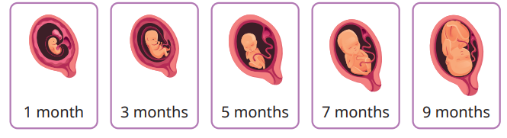 | • What is sexual reproduction? • How many parents are involved in sexual reproduction? • What is the male sex cell called? • What is the female sex cell called? • Where are male sex cells produced? • Where are female sex cells produced? • What happens during fertilisation? • What is an embryo? • What is a foetus? • Where does a foetus develop inside a mammal? | Fertilisation, embryo, sperm cells, egg cells, sexual reproduction | Sexual reproduction involves two parents producing offspring.  • Offspring produced by sexual reproduction are not identical to the parents.  • Fertilisation is the process by which a sperm cell joins with an egg cell to create a new life |   
2 | • Describe the life process of reproduction in some plants and animals. • Working scientifically − Recording data and results of increasing complexity, using scientific diagrams and labels, classification keys, tables, scatter graphs, bar charts and line graphs. | In this step, children learn the names and functions of the specific male and female reproductive parts in plants. The female pistil is made up of the stigma, style and ovary and the female sex cells are ovules. The male stamens are made up of the anther and filament and the male sex cells are pollen. In this step, children can work practically by carrying out a plant dissection to identify the reproductive parts of a flowering plant. To extend learning, children could dissect different types of flowering plants and compare the reproductive parts.  In groups, children could complete a plant dissection to identify the different reproductive parts of a flowering plant. Encourage children to group the male and female reproductive parts. Ask them to write a description of the function of each reproductive part on cards and use the cards to label their dissection  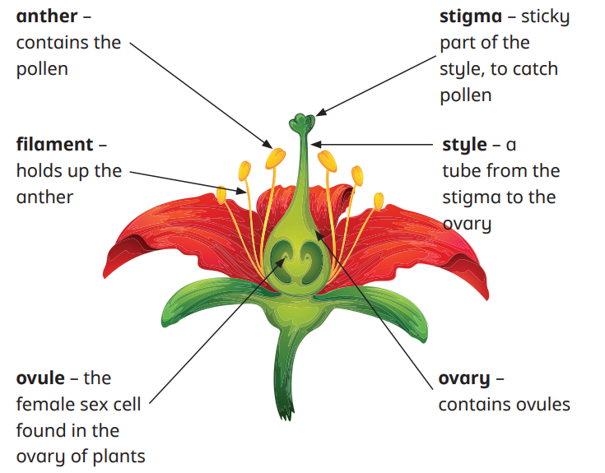 | • What are the male reproductive parts of a flowering plant called? • What are the female reproductive parts of a flowering plant called? • What parts of a plant are collectively known as the stamen? • What parts of a plant are collectively known as the pistil? • What is the function of an anther/filament/stigma? • What is the male sex cell in flowering plants called? • What is the female sex cell in flowering plants called? | Anther, filament, ovule, stigma, style,ovary,ovule | • The female part of a flowering plant is called the pistil, which consists of the stigma, style and ovary.  • The male part of a flowering plant is called the stamen, which consists of the anther and filament.  • The female sex cells in a plant are called ovules and are found in the ovary.  • The male sex cells in a plant are called pollen grains and are found on the anthers | 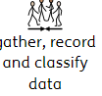
3 | • Describe the life process of reproduction in some plants and animals. • Working scientifically − Reporting and presenting findings from enquiries, including conclusions, causal relationships and explanations of and a degree of trust in results, in oral and written forms such as displays and other presentations. | By the end of this step, children should understand that plants can reproduce sexually through pollination, building on their knowledge from Year 3. Children should be aware that many plants cannot pollinate themselves and that they rely mainly on pollinators or wind to transfer the pollen to other plants. Once the pollen grain has attached to the stigma, it travels down the style into the ovary and joins with an ovule – this is fertilisation. The fertilised ovule will then turn into a seed, which can then be dispersed to grow into a new plant.  In groups, ask children to model the pollination process. Some act as flowering plants and some act as insects. Each “flowering plant” has five counters of the same colour, representing pollen grains. The “insects” collect a counter every time they brush past a plant. They then give this to another plant. At the end, the flowering plants should have a collection of different-coloured counters, representing pollen grains from different plants. | • What is pollination? • What are the male parts of a flowering plant called? • What are the female parts of a flowering plant called? • Which part of a plant produces pollen? • What happens when pollen attaches to the stigma? • How does an insect/wind pollinate a plant? • What happens during fertilisation in plants? • How are seeds made? | Pollen, ovule, pollination, fertilisation | • Plants reproduce sexually through pollination.  • Pollination involves the transfer of pollen from the male anther of a flowering plant to the female stigma of a flowering plant.  • Pollen grains attach to the sticky stigma and travel down the style into the ovary.  • Fertilisation occurs when a male pollen grain joins with a female ovule inside an ovary
4 | • Describe the life process of reproduction in some plants and animals. • Working scientifically − Identifying scientific evidence that has been used to support or refute ideas or arguments. | By the end of this step, children should be able to give examples of plants that can carry out asexual reproduction. Certain plants, such as daffodils and onions, can reproduce asexually by producing bulbs. Other plants, such as potatoes, create tubers. Bulbs and tubers stay beneath the soil and eventually develop into a new plant in the soil. Strawberries produce new plants at the ends of runners. An example of asexual reproduction in animals is starfish. Introduce children to the fact that humans have cloned animals, such as Dolly the sheep  Ask children to research Dolly the sheep and animal cloning in groups and present their findings to the class. Children can then discuss whether they are for or against the cloning of animals. Encourage children to work scientifically by using scientific evidence to support their ideas | • What is asexual reproduction? • What is the difference between asexual reproduction and sexual reproduction? • How does the appearance of offspring produced by asexual reproduction compare with that of the parent? • Which type of plant can reproduce asexually? • Which plants produce bulbs? • Which plants produce tubers? • Do any animals reproduce asexually? • What type of animal has been cloned by humans? | Clone, runner, tuber, bulb, asexual reproduction | • Asexual reproduction involves only one parent.  • Offspring produced by asexual reproduction are identical to the parent. • Some plants reproduce asexually by producing new plants at the end of runners or by producing bulbs or tubers. • A starfish is an example of an animal that reproduces asexually | 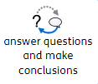
5 | • Describe the life process of reproduction in some plants and animals. • Working scientifically − Planning different types of scientific enquiries to answer questions, including recognising and controlling variables where necessary. | In this step, children should plan their investigation and identify which parts of the parent plant they will use to try and clone plants. They should make a prediction as to which cutting will produce the tallest plant.  Equipment needed • parent plants • scissors • plant pots • compost or soil • clear plastic bags • water • scales • rooting powder or gel • ruler  Practical activity • Put children in small groups. Give each group the equipment needed for the experiment. Children should identify what the equipment is and why it is used within the experiment. • Children could practise measuring the lengths of different plant parts with a ruler in preparation for their investigation.  Planning sentence stems • I predict that … I think this will happen because … • We are changing the … • We are measuring the … • We are keeping the the same | • What is asexual reproduction?  • Which plants reproduce asexually by producing bulbs/ tubers/runners? • What is a cutting? • Which parts of the plant will you use as cuttings to grow a new plant? • Which cuttings do you predict will grow into a new plant? • Which plant cutting do you predict will produce the tallest plant? | Independent variable, dependent variable, controlled variable | • What is asexual reproduction?  • Which plants reproduce asexually by producing bulbs/ tubers/runners?  • What is a cutting?  • Which parts of the plant will you use as cuttings to grow a new plant?  • Which cuttings do you predict will grow into a new plant?  • Which plant cutting do you predict will produce the tallest plant? | 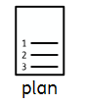
6 | • Describe the life process of reproduction in some plants and animals. • Working scientifically − Taking measurements, using a range of scientific equipment, with increasing accuracy and precision, taking repeat readings when appropriate. | In this small step, children begin their investigation by taking their cuttings from parent plants. Ensure they use equipment safely when taking their cuttings. They measure the initial length of their cuttings with a ruler. They should then plant the cuttings in some compost, using rooting powder or gel to encourage growth of the plants. The plants should be kept away from direct sunlight and should be covered with a clear plastic bag to keep them moist. Children should make observations and measure their cuttings over the next six weeks. They will measure the final length of their plants and present their findings from the investigation in Summer Block 4  Equipment needed • parent plants • scissors • plant pots • compost or soil • clear plastic bags • water • scales • rooting powder or gel • ruler  Method 1. Use the scales to measure an equal mass of compost in each plant pot. 2. Use scissors to produce cuttings from two different parts of the parent plant, e.g. roots, leaves or the stem. 3. Measure the initial length of each cutting. 4. Dip part of each cutting in water. 5. Dip the same part of each cutting in rooting powder. 6. Plant each cutting in a plant pot. 7. Label each pot with the name of the plant part used. 8. Cover the plant pots with a clear plastic bag to keep them moist. 9. Place the plant pots in a position which is not in direct sunlight. Plant – clone plants 10. Record weekly observations | • Which two plant parts will you use to make cuttings? • Which cutting do you predict will grow into a new plant? • Do you predict any cutting will not grow into a new plant? • What equipment do you need to do this investigation? • Why should you cover your plants with a clear plastic bag? • What is rooting powder/gel? | Clone, cutting, parent plant, compost | • What is asexual reproduction?  • Which plants reproduce asexually by producing bulbs/ tubers/runners?  • What is a cutting?  • Which parts of the plant will you use as cuttings to grow a new plant?  • Which cuttings do you predict will grow into a new plant?  • Which plant cutting do you predict will produce the tallest plant? | 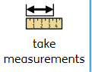
7 reversable and irreversible change | • Know that some materials will dissolve in liquid to form a solution, and describe how to recover a substance from a solution. • Working scientifically − Using test results to make predictions to set up further comparative and fair tests. | Children should work scientifically by identifying whether a substance is soluble or insoluble and predict how other soluble substances behave.  In groups, children can attempt to dissolve different substances in water, such as salt, sand, rice, flour, coffee and sugar. This is to determine which substances are soluble and which are insoluble. This could be extended to investigate how we can speed up the rate of dissolving. Children could repeat this activity by using cold and warm water or stirring the liquid, to see if the different conditions affect the rate that the substance dissolves. | • What does “dissolving” mean? • What is a substance? • What is a solution? • What does “soluble” mean? • What does “insoluble” mean? • Is salt soluble or insoluble in a liquid? • Is sand soluble or insoluble in a liquid? • How can you tell if a substance has dissolved in a liquid? • How does temperature affect the rate of dissolving? • What is the difference between melting and dissolving? | Dissolve, soluble, insoluble, solution, substance | • A soluble substance can dissolve in a liquid.  • Salt and sugar are soluble in a liquid.  • An insoluble substance cannot dissolve in a liquid.  • Sand and flour are insoluble in a liquid.  • To make a solution, a substance is dissolved into a liquid.  • Increasing the temperature of the liquid increases the rate of dissolving. • Stirring the liquid increases the rate of dissolving |   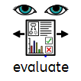
8 | • Use knowledge of solids, liquids and gases to decide how mixtures might be separated, including through filtering, sieving and evaporating. • Working scientifically – Recording data and results of increasing complexity using scientific diagrams and labels, classification keys, tables, scatter graphs, bar and line graphs. | Children should work practically by filtering and sieving different mixtures, using a range of scientific equipment. They should be able to identify equipment, such as a sieve, funnel and filter paper. | • Which substances are soluble in water? • Which substances are insoluble in water? • What type of mixture can be separated by sieving? • What type of mixture can be separated by filtering? • How can sand be separated from rice? • How can sand be separated from water? • What equipment is needed for filtering? • Why can sugar and water not be separated by filtering? | Sieve, filter paper, mixture, insoluble, filtering, funnel | • Sieving can be used to separate a mixture of different-sized solids.  • Filtering can be used to separate an insoluble solid from a liquid.  • A liquid will pass through filter paper, but an insoluble solid will not.  • Filtering cannot be used to separate a soluble solid from a liquid.
9 | • Use knowledge of solids, liquids and gases to decide how mixtures might be separated, including through filtering, sieving and evaporating. • Working scientifically − Taking measurements, using a range of scientific equipment, with increasing accuracy and precision, and taking repeat readings when appropriate. | In the previous step, children focused on the process of sieving and filtering to separate insoluble solids from a mixture. They should understand that “soluble” refers to a substance that can dissolve in a liquid to make a solution. Children work practically in this step by using scientific equipment to separate a soluble solid from a liquid by evaporation. They should take measurements of the salt, water and the time it takes to retrieve the salt from the solution  • Mix a quarter of a teaspoon of salt with a tablespoon of warm water. Dissolve the salt in the water to form a solution. Transfer this solution into a Petri dish or other shallow container. Ask children to predict whether the salt can be separated from the water. Leave the container on a hot radiator or use a hairdryer on a medium setting to heat the surface of the water. Once the water has evaporated, there should be salt crystals left in the container. Ensure the solution is observed at regular intervals to prevent overheating or excess drying. | • What is a solution? • Is soluble or insoluble in a liquid? • How can you separate sand/salt from a liquid? • Why can filtration not be used to separate salt from a liquid? • Why can sieving not be used to separate sugar from a liquid? • What happens when salt is added to water? • What is evaporation? | Solution, dissolve, soluble, insoluble, evaporation | • Evaporation is the change of state from a liquid to a gas which happens slowly from the surface of a liquid.  • Evaporation can be used to separate a soluble solid from a liquid.
10 | • Demonstrate that dissolving, mixing and changes of state are reversible changes. • Working scientifically − Use relevant scientific language and illustrations to discuss, communicate and justify their scientific ideas (non-statutory). | In this step, children begin an identifying, grouping and classifying enquiry to identify and categorise different processes. Encourage children to make their own decisions about which observations are appropriate for identifying whether or not a change is reversible.  • In small groups, children attempt to reverse a number of different changes. These could include freezing water into an ice cube, dissolving salt in water and mixing rice with gravel and stones. Ensure children have access to sieves with different sized holes. Encourage children to notice that all of these changes can be reversed because you can retrieve the substances that you started with.  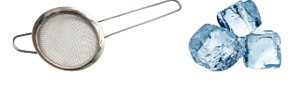 | • What are the three states of matter? • What is melting/condensation/evaporation? • Water is cooled in a freezer. It forms ice. How can the ice change state to water? • Some salt is dissolved in water. How can this be reversed? • What is a reversible change? • What are two examples of reversible changes? | Mixture, states of matter, dissolve, reversible change, reverse | • The three states of matter are solids, liquids and gases. • Some changes can be reversed, such as dissolving, mixing and changes of state. • Changes of state include freezing, melting, evaporation and condensation. • If you can retrieve the substances that you started with, then the change is reversible.
11 | • Explain that some changes result in the formation of new materials, and that this kind of change is not usually reversible, including changes associated with burning, and the action of acid on bicarbonate of soda. • Working scientifically − Use relevant scientific language and illustrations to discuss, communicate and justify their scientific ideas (non-statutory) | In this small step, children focus on the irreversible change of burning. Once a material has been burnt, it cannot be changed back to its original form. It is important that the children explore real-life examples, such as burning a match or the wick of a candle. Children should continue to think about the enquiry question in this step, by considering which changes are irreversible  Children should observe a variety of different irreversible changes, such as burning a piece of toast, burning the wick of a candle or burning a match. Heating water could be included to offer comparison between heating and burning. Encourage children to discuss the difference between heating water and burning a piece of toast.   | • What is an irreversible change? • What are some examples of irreversible changes? • Are changes of state reversible or irreversible changes? • Why is burning an irreversible change? • What are some examples of burning? | Chemical reaction, reversible change, irreversible change, burning, heating | • An irreversible change is when a change cannot be undone to get the same substances back again.  • Irreversible changes result in new substances being made.  • When a new substance is made, a chemical reaction has taken place.  • Burning is an example of an irreversible change.
 | • Explain that some changes result in the formation of new materials, and that this kind of change is not usually reversible, including changes associated with burning and the action of acid on bicarbonate of soda. • Working scientifically − Identifying scientific evidence that has been used to support or refute ideas or arguments. | In this step, children will be looking at the reaction between an acid and bicarbonate of soda. For safety, the acid used for this reaction can be vinegar. The reaction of rocks with acid has already been explored in Year 3. Children should react an acid with bicarbonate of soda and find that it fizzes. This means that a gas has been made. Fizzing is one sign that a chemical reaction has taken place, and a new substance (such as a gas) is made. Children should form an answer to the enquiry question within this step and should demonstrate their understanding of irreversible and reversible changes. | • What is meant by an “irreversible” change? • What is the difference between a reversible and an irreversible change? • What happens when the acid is added to bicarbonate of soda? • What new substance is formed? • What is meant by a “chemical reaction”? | Irreversible change, chemical reaction, vinegar, bicarbonate soda | • Irreversible changes (such as burning and reactions with acids) cannot be reversed, and they result in new substances being made.  • When a new substance is made, a chemical reaction has taken place.  • When a substance fizzes, a gas has been made.
12 |  | End of unit assessment, complete and send scored to ND for monitoring,

