 | National curriculum | Lesson outline | Key questions | Key vocab | Factual knowledge | Scientific enquiry
1/2 | • Compare and group together everyday materials on  the basis of their properties, including their hardness,  solubility, transparency, conductivity (electrical and  thermal) and response to magnets.  • Working scientifically − Use and develop keys and  other information records to identify, classify and  describe living things and materials (non-statutory). | Lesson 1- Book lesson- grouping objects  In this small step, children test everyday materials and group  them based on their transparency, hardness and magnetism.  They also link the properties of materials to their uses. Within  younger year groups-, children have looked at these concepts  but they will need to be revisited within this step. There are a  variety of methods to test the hardness of materials. Testing for  hardness can be comparative. Children should understand that  a harder material will scratch a softer material.  Children should be encouraged to group the materials they have  tested in different ways based on a range of categories. It is  important that children are encouraged to group the materials  into more than just two groups, to challenge their understanding  of the properties of materials.  Lesson 2- floor book lesson- testing objects  • Give children a selection of copper and silver coins.  Try to ensure that some of the 5p and 10p  coins were made before 2012 and some  were made after 2012. Coins made after  2012 are made from plated steel and  so are magnetic.  Test the coins with a magnet to see  which are magnetic.  Ask the children to group the coins based on whether or not  they are attracted to a magnet. | • What does “magnetic” mean?  • Is a magnetic material?  • Are all metals magnetic?  • What do the terms “translucent”, ”transparent” and “opaque”  mean?  • How could two materials be tested to see which one is  the hardest?  • Which material do you think is the hardest? | Transparent, translucent, opaque, magnetism, hardness | actual knowledge  • Materials can be transparent, translucent or opaque.  • A harder material will scratch a softer material.  • Most metals are non-magnetic. Only a few metals are  magnetic, such as iron and steel. |   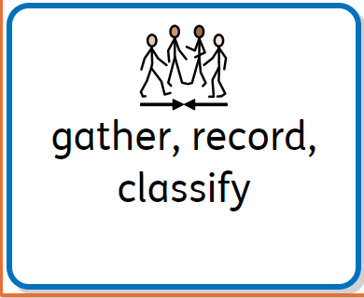
3/4 | Compare and group together everyday materials on  the basis of their properties, including their hardness,  solubility, transparency, conductivity (electrical and  thermal) and response to magnets.  • Working scientifically − Recording data and results  of increasing complexity using scientific diagrams and  labels, classification keys, tables, scatter graphs, bar and  line graphs. | Lesson 1- Book lesson complete knowledge and create a sheet to reflect the one from white rose. In this small step, children test some everyday materials and  group them based on their electrical conductivity. This step  builds on the electricity block studied in Year 4. The materials  will be classified as conductors or insulators.  By the end of this step, children identify that conductors allow  electricity to pass through them easily and can complete an  electrical circuit. They should also be aware that non-conductors  (insulators) do not let electricity pass through them.  Children should build circuits to test whether different materials  can conduct electricity. They may need to recap how to build  a working circuit before completing this step. Children should  only use a battery, bulb and wires in their circuit. They should  draw the circuit pictorially. Conventional circuit symbols will be  introduced in Year 6  Lesson 2 floor book- experiment  Give children a selection of materials such as plastic, wood,  paper and different types of metal.  Ask children to build a series circuit to test whether the  different materials can conduct electricity or not. This can be  done by leaving a gap in the circuit for the materials to be  added in to complete the circuit.  Encourage children to predict whether the material will be an  insulator or a conductor of electricity before each test. | • What does “electrical conductor” mean?  • What does “electrical insulator” mean?  • What components are needed in a complete circuit?  • Is a conductor of electricity?  • How would you know that is a conductor  of electricity?  • Electrical wires are covered with a plastic casing. Why is  plastic used? | Electrical conductor, electrical insulator, circuit, cell, bulb | • An electrical conductor is a material that allows electricity to  flow through it.  • An electrical insulator is a material that does not allow  electricity to flow through it.  • Metals are good electrical conductors.  • Plastic, wood and paper are electrical insulators
5/6 | • Compare and group together everyday materials on  the basis of their properties, including their hardness,  solubility, transparency, conductivity (electrical and  thermal) and response to magnets.  • Working scientifically − Planning different types of  scientific enquiries to answer questions, including  recognising and controlling variables where necessary. | Lesson 1- planning – Lesson 2 Experiment  In this small step, children plan a comparative test to investigate  which material is the best thermal insulator. Over the next three  steps, children explore which material is the best at keeping hot  water warm. Children learn that a thermal insulator is a material  that prevents heat passing through it. They should choose three  different materials, such as bubble wrap, aluminium foil and  felt, to wrap around the beakers filled with hot water. Alongside  this, children should have a beaker that is not wrapped in any  material. This beaker provides a control that they can use to  measure temperature differences against.  Children have learnt how to use a thermometer in Year 4 (States  of matter block) to accurately measure the temperature of  water over time. However, this skill may need practising prior to  the investigation. Within this step, children should create their  experiment plan and identify the independent, dependent and  controlled variables  Equipment needed  • four same-sized beakers  • aluminium foil  • cloth  • bubble wrap  • four thermometers  • hot water  • stopwatch  or timer  Practical activity  • Put children in small groups.  Give each group the equipment needed  for the experiment.  Children should identify what the equipment  is and why it is used within the experiment.  Planning sentence stems  • I predict that …  I think this will happen because …  • We are changing the …  • We are measuring the …  • We are keeping the the same | • What is a thermal insulator?  • When would you need to keep something hot?  • When would you need to keep something cold?  • What are the independent, dependent and controlled  variables in this experiment?  • What equipment will you use and why?  • How will you record your results? | Independent variable. Dependent variable. |  | 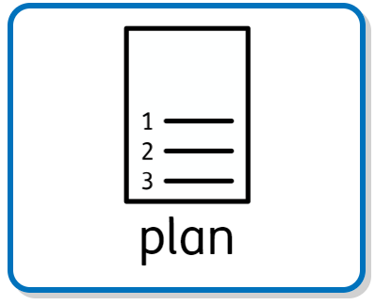
7/8 | • Compare and group together everyday materials based  on their properties, including their hardness, solubility,  transparency, conductivity (electrical and thermal) and  response to magnets.  • Working scientifically − Taking measurements, using a  range of scientific equipment, with increasing accuracy  and precision, taking repeat readings when appropriate. | In this small step, children carry out a comparative test to  explore which materials are the best insulators of heat. Before  they begin the investigation, Lesson 1 children should be encouraged to recap their experiment plan and identify the independent,  dependent and controlled variables.  Lesson 2  children should set up their own  investigations more independently, including the control beaker.  They should identify that the control beaker is one without any  layers of material insulation. They should be able to identify  that having a control beaker allows them to compare the  temperature change of water in an uninsulated beaker with the  temperature changes of water in beakers with different types  of insulating layers.  Equipment needed  • four same-sized beakers  • aluminium foil  • felt  • bubble wrap  • four thermometers  • hot water  • stopwatch  Method  1. Get four beakers of the same size.  2. Wrap three beakers in one layer of material – aluminium foil,  felt and bubble wrap.  3. Leave one beaker without insulating material to use as a  control.  4. Add hot water (no hotter than 50°C) to each beaker.  5. Record the starting temperature of each beaker. Leave the  thermometer in each beaker to avoid delays in recording the  data at each interval.  6. Record the temperature of each beaker at five-minute  intervals.  7. Repeat this process for 30 minutes.  8. Ask children to identify which material is the best insulator  of heat | What is a thermal insulator?  • What is your experiment plan?  • What is your prediction for the experiment?  • Why was one of the beakers not covered in insulation?  • What did you notice about the temperature of all four  beakers at the end of the experiment? | Thermal insulator, thermometer, control beaker, temperature | • When setting up the experiment, the temperature of the  water should not exceed 50°C to align with health and  safety regulations.  • Children may think that their results are inaccurate once  all four beakers have reached room temperature and  the temperature in each beaker is the same | 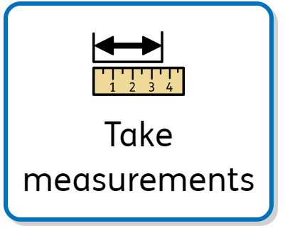
9 | • Compare and group together everyday materials based  on their properties, including their hardness, solubility,  transparency, conductivity (electrical and thermal) and  response to magnets.  • Working scientifically − Using test results to make  predictions to set up further comparative and fair tests | Lesson 1- Evaluate  In this small step, children work scientifically to analyse data,  make conclusions and evaluate the insulation experiment  from Step 4. Children can use the evaluation sentence stems to  structure their written analysis and evaluation.  Within this step, children should use their data to explain which  material was the best insulator of heat. Children should be  encouraged to refer to the control beaker within their evaluation.  This will allow them to make a comparison between the insulated  beakers and the non-insulated beaker.  Children should be given the opportunity to answer the enquiry  question and discuss which material is the best insulator of heat.  They should determine that the best insulating materials will  slow down the warm air passing through the insulation  Practical ideas  • Children could extend the experiment to test whether the  material that keeps the water hottest for longest is also the  material that keeps ice coldest for longest.  Children could wrap ice cubes in different materials and  record the loss in mass after 10 minutes.  The material that leads to the least loss in mass  will be the best insulator.  One of the ice cubes should be uncovered for  comparison.  Evaluation sentence stems  • I predicted that …  My prediction was correct/incorrect because …  • From looking at our results, I can see that …  This happened because …  • Our results are/are not reliable because …  • To make our investigation more accurate, we could …  • For future investigation, I would like to find out | • What do the results tell you about which material is the best  insulating material?  • If you were to repeat this experiment, how could you improve  your results?  • How could you make your results more reliable?  • What questions do you have for further investigation? | Thermal insulator, data, temperature, conclusion, anomalous result | • | 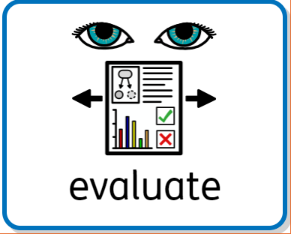
10/11 | • Give reasons, based on evidence from comparative and  fair tests, for the particular uses of everyday materials,  including metals, wood and plastic.  • Working scientifically − Use relevant scientific language  and illustrations to discuss, communicate and justify  their scientific ideas (non-statutory). | Lesson 1- Book lesson  In this small step, children look at three common materials,  plastic, wood and metal, and link the uses of these materials to  their properties. In this block, children have completed a variety  of tests to explore electrical and thermal conductivity as well as  hardness, transparency and magnetism.  When thinking about the uses and suitability of materials  for different purposes, children should be encouraged to use  evidence from their own testing to explain why a material would  be suitable or unsuitable for use.  Children should identify that some materials have the same uses  and all the different properties must be considered to make a  justified decision on which material is best for the particular use.  Sometimes, two or more of the materials can be correct  Lesson 2- Practical lesson- floor book lesson  • Give children a selection of metals, plastics and wood.  Ask them to test the properties of different materials.  Example questions are listed below. Children could record  results in a table.  • Are they magnetic?  • Are they hard or soft?  • Are they flexible or rigid?  • Are they waterproof?  • Can they be recycled?  • Are they expensive or cheap?  • Can they conduct heat or electricity?  Children should use their own testing and findings from  previous steps when defining materials. They should be  encouraged to think about when these materials would be  suitable or unsuitable for a particular purpose | • What is an electrical conductor?  • What is an electrical insulator?  • What is a thermal insulator?  • What object is this?  What material is it made from?  What other materials could this object be made from?  • Why is a suitable material for a ?  • Why would be unsuitable for a ? | Properties, wood, metal, plastic, lifespan | • Materials have specific uses.  • Metals are good conductors of electricity and heat.  • Plastics are good insulators of electricity | 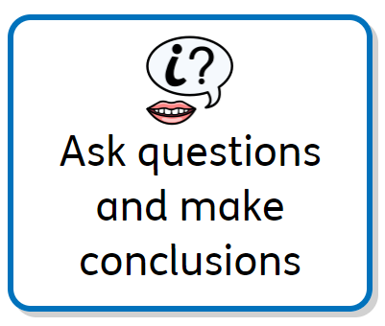
12 |  | End of unit assessment, complete and send scored to ND for monitoring,
13/14 | NEW topic Animals including humans  • Describe the changes as humans develop to old age.  • Working scientifically – Planning different types of  scientific enquiries to answer questions, including  recognising and controlling variables where necessary. | Lesson 1  In this small step, children learn how humans grow and develop.  They look at the six stages of the human life cycle − foetus, baby,  child, adolescent, adult and elderly adult. Children briefly look  at the key features of each stage of the human life cycle, but will  explore each stage in more detail throughout this block.  Encourage children to explore where they and other familiar  people (such as teachers and family members) are within the  life cycle. Children should understand that babies, children and  adolescents grow rapidly in terms of mass and height. They tend  to reach a peak in their growth when they become an adult.  Children do not need to look at the stages of foetal development  or the process of conception within this step, as this is covered in  later curriculum.  Lesson 2  • Split the class into small groups.  Give each group a stage of the human life cycle.  baby  0–1  child  2–10  adolescent  11–17  adult  18–64  elderly adult  65+  Children could research the main changes that occur within  that life stage and present findings back to the class.  • Create a whole-class timeline using photos of children, staff  and parents/carers, with permission.  Children could discuss key features of each life stage by  observing photos. | • What are the six stages of the human life cycle?  • Around what age is a human described as a baby?  • Around what age is a human described as a child?  • In which life stages do humans grow the most?  • What is the difference between a foetus and a baby?  • How might a human look different as an elderly adult  compared to an adult?  • During which stage of the human life cycle might a human  have a baby?  • Where does a foetus grow and develop? | Adolescent, baby, foetus, elderly adult, adult, lifecycle | • The human life cycle has six main stages – foetus, baby, child,  adolescent, adult and elderly adult.  • Every human goes through the same life stages in the same  order.  • All humans start their life as a foetus inside their mother’s  womb.  • After puberty, humans can reproduce | 

