Computing Medium Term Planning
Term: Autumn 1 | Year: 1/2 | Topic/Unit: 1.5 Maze Explores and 2.7 Making Music
Key Vocabulary
Lesson 1- Direction, left and right, challenge, undo, route, delete, command, unit
Lesson 2- Algorithm, instruction, direction, challenge, route, command
Lesson 3- Algorithm, left and right, undo, delete, unit, instruction, direction, challenge, route, command
Lesson 4- Algorithm, left and right, undo, delete, unit, instruction, direction, challenge, route, command, background

Lesson 5- Tune, compose, note, speed, beat, volume

Lesson 6- Tempo, sound effect, repeat, bars

Lesson 7- Tune, compose, note, speed, beat, volume, tempo, sound effect, repeat, bars, soundtrack
Evidence: Please can all class teachers generate an example of work that is Working towards, Working at and Working to GD for each unit and upload them to the computing curriculum folder (or email to Kathryn) for monitoring. Evidence is collected for Computing Folder in SLT room.
National Curriculum | Week | NC Coverage | Skills taught | Knowledge | Activity Outline
• To understand the functionality of the basic direction keys in Challenges 1 and 2.  • To be able to use the direction keys to complete the challenges successfully.  • To understand the functionality of the basic direction keys in Challenges 3 and 4.  • To understand how to create and debug a set of instructions (algorithm).  • To use the additional direction keys as part of their algorithm.  • To understand how to change and extend the algorithm list.  • To create a longer algorithm for an activity.  • To provide an opportunity for the children to set challenges for each other.  • To provide an opportunity for the teacher to add these challenges to a display board for the class to try.  • To be introduced to making music digitally using 2Sequence.  • To explore, edit and combine sounds using 2Sequence.  • To add sounds to a tune to improve it.  • To think about how music can be used to express feelings and create tunes which depict feelings.  • To upload a sound from a bank of sounds into the Sounds section.  • To record their own sound and upload it into the Sounds section.  • To create their own tune using the sounds which they have added to the Sounds section. | 1  Unit 1.5  Lesson 1  Challenges 1 and 2 | • To understand the functionality of the basic direction keys in Challenges 1 and 2.  • To be able to use the direction keys to complete the challenges successfully. | Able to use direction keys to make movements.  Able to add a unit of measurement to the direction.  Able to undo a last movement. | • Children know how to use the direction keys in 2Go to move forwards, backwards, left and right.  • Children know how to add a unit of measurement to the direction in 2Go Challenge 2.  • Children know how to undo their last move.  • Children know how to move their character back to the starting point. | Preparation  • 2Go: Lesson 1 Challenge 1  • 2Go: Lesson 1 Challenge 2  Select the following objectives when setting the 2Do:  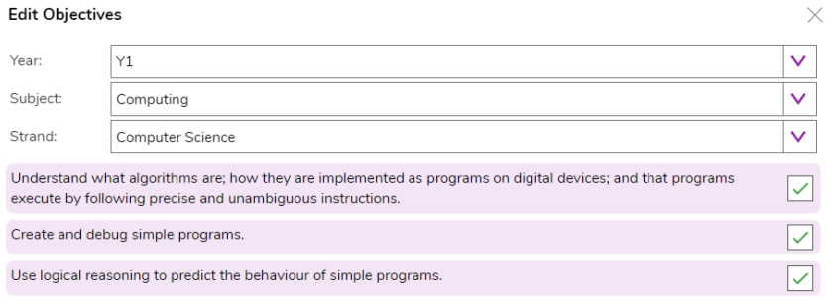  Lesson outline:  Slide 5: Introduce the program 2Go from the tools section of Purple Mash.  Activity 1: Challenge 1  Slide 6: Use slide 6 to open Challenge 1. Demonstrate how to use the direction keys to move the fish around the screen  Use slide 7 to ensure children understand the program and use the suggested questions to ensure children understand what the challenge is asking them to do. When confident, allow them to have a go on their devices. (Setting Challenge 1 as a 2Do enables quick access to this challenge from the 2Do area).  Activity 2: Challenge 2  Use slide 8 to introduce Challenge 2. (Click on the link to open Challenge 2). Discuss the questions first then click to reveal answers.  Use slide 9 to ensure children understand the program and use the suggested questions to ensure children understand what the challenge is asking them to do. When confident, allow them to have a go on their devices. (Setting Challenge 2 as a 2Do enables quick access to this challenge from the 2Do area).  Use slide 10 to suggest other things the children can try after they have reached the bank and hospital. Children can explore another scene by clicking new, then using the white arrow keys to scroll through different backgrounds.  Plenary:  Review meaning of vocabulary (click on words to reveal the definitions)
 | 2  Unit 1.5  Lesson 2  Challenges 3 and 4 | • To understand the functionality of the basic direction keys in Challenges 3 and 4.  • To understand how to create and debug a set of instructions (algorithm). | To create a simple algorithm.  To debug an algorithm.  To move characters diagonally. | • Children can use diagonal direction keys to move the characters in the right direction.  • Children know how to create a simple algorithm.  • Children know how to debug their algorithm | Preparation:  • 2Go: Lesson 2 Challenge 3  • 2Go: Lesson 2 Challenge 4  • Extension activities for the 2Go challenges can be found at: Extension Activity 1 – Lesson 2 Level 1  Extension Activity 2 – Lesson 2 Level 2  • You can select the following objectives when setting the 2Do to make future assessment easier:  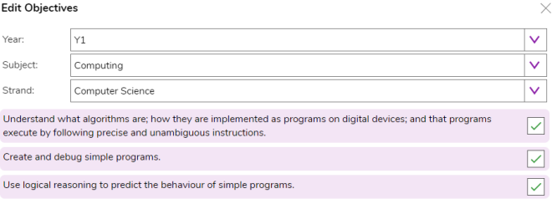  Lesson outline:  Slide 6 – Open challenge 3. Use slide 7 to talk through challenge 3. Show children that the next island they need to go to will light up. When confident, allow them to have a go on their devices. (Setting Challenge 3 as a 2Do enables quick access to this challenge from the 2Do area).  Challenge 4 - Use slide 8 to introduce challenge 4. Click on the link in the slide to open challenge 4. Use slide 9 to explain what they need to do and demonstrate as a whole class. After demonstrating the challenge, share slide 10 and let the children have a go on their own devices. (Setting Challenge 4 as a 2Do enables quick access to this challenge from the 2Do area).  When children have had a try themselves, share the solution on slide 11 and replicate on the program. Read the instructions out with the children and go through the route before you press play.  Plenary:  Review meaning of vocabulary (click on words to reveal the definitions)
 | 3  Unit 1.5  Lesson 3  Challenges 5 and 6 | • To use the additional direction keys as part of their algorithm.  • To understand how to change and extend the algorithm list.  • To create a longer algorithm for an activity | Able to use additional direction keys as part of their algorithm.  Create a longer algorithm. | • Children can use the additional direction keys to create a new algorithm.  • Children can challenge themselves by using the longer algorithm to complete challenges. | Preparation:  • 2Go: Lesson 3 Challenge 5  • 2Go: Lesson 3 Challenge 6  • Additional extension activities for the 2Go challenges can be found at:  Extension Activity 1 – Lesson 3 Level 1  Extension Activity 2 – Lesson 3 Level 2  • You can select the following objectives when setting the 2Do to make future assessment easier:  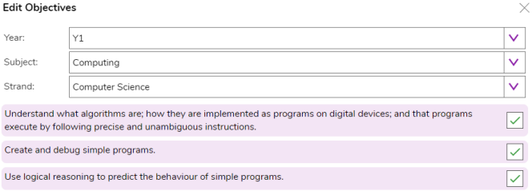  Lesson outline:  Challenge 5: Use slide 6 to introduce and demonstrate challenge 5. The new program list will give the children the opportunity to create a longer program and may help them with the next activities.  Children can have a go at challenge 5. (Setting challenge 5 as a 2Do enables quick access to this challenge from the 2Do area). Use the questioning on slide 7 to extend children.  Challenge 6: Demonstrate challenge 6 on slide 8. Children can have a go at challenge 6. (Setting challenge 6 as a 2Do enables quick access to this challenge from the 2Do area). Use the questioning on slide 9 to extend children.  When children have had a try themselves, share the solution on slide 10 and replicate on the program. Read the instructions out with the children and go through the route before you press play.  Plenary:  Review meaning of vocabulary (click on words to reveal the definitions)
 | 4  Unit 1.5  Lesson 4  Setting More Challenges | • To provide an opportunity for the children to set challenges for each other.  • To provide an opportunity for the teacher to add these challenges to a display board for the class to try | Set a challenge independently. | • Children can change the background images in their chosen challenge and save their new challenge.  • Children have tried each other’s challenges. | Preparation:  • 2Go, which can be found on Purple Mash in the Tools area. • You can select the following objectives when setting the 2Do to make future assessment easier:  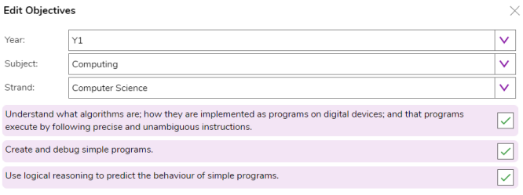  Lesson outline:  Go through Purple Mash lesson 4 slides.  Activity 1: Use slide 6 to demonstrate how to create their own challenge. Let children work in pairs to set each other challenges to complete.  Activity 2: After giving the children time to do the activity, use slide 7 to help children evaluate their challenges. You might want children to share their activities to a class display board so they can try a range of their peers’ activities. (See the Display Boards Guide for instructions.)  Extension: Use slide 8 to display an optional extension task.  Plenary: To review lesson vocabulary. Click on the words to reveal the definitions. Children can rate how they achieved the success criteria using hands.
 | 5  Unit 2.7  Lesson 1  Introducing 2Sequence | • To be introduced to making music digitally using 2Sequence.  • To explore, edit and combine sounds using 2Sequence. | Use the different sounds within 2sequence to create a tune.  Explore how to speed up and slow down tunes.  Explore, edit and combine sounds. | • Children understand what 2Sequence is and how it works.  • Children have used the different sounds within 2Sequence to create a tune.  • Children have explored how to speed up and slow down tunes.  • Children understand what happens to the tune when sounds are moved. | Preparation:  Set up 2Sequence tool on 2Do.  Lesson:  Introducing 2Sequence: Display slide 5. Show the children 2Sequence as a class and explain to them that it will let them explore lots of musical sounds and make their own music. Play the Twinkle Twinkle sample composed on 2Sequence. Do the children recognise it? Open 2Sequence. You can either follow the instructions about how to open it or click in the link on the top right of the screen.  Adding Instruments: Display slide 6. Start with a simple pattern of sounds. Select the bells and chimes from the bottom of the screen.  Using the bells and chimes, show the children how to drag each instrument onto a bar. Show how to use the bin to delete unwanted notes. Demonstrate how to run the sequence by clicking on the big green for ‘go’ arrow at the top of the screen. Show the children how each bar is highlighted as the tune is played.  Changing the speed of your tune: Display slide 7. Demonstrate how to slow down and speed up the tune by using the bpm (beats per minute) slider. Open up Twinkle Twinkle again. Speed up and slow down the tune. Which version did the children like the best: the fast one or the slow one?  Activity 1: Display slide 8. Let the children try for themselves. They should only use the ‘Bells and Chimes’. At this point, you may want the children to use headphones so that they can only hear the tunes that they are creating.  Display slide 9. Show them how to select another set of instruments from the bottom of the page. Select the drums. Demonstrate how to listen to and then add drums. Explain to the children they can leave a gap between their drumbeats. They don’t have to fill every box.  Activity 2: Display slide 10. The children return to their devices and add drums to the tune they have composed.  Display slide 11. Clear your tune and start again by clicking on the ‘New’ icon in the top left burger menu. Select the violins from the instrument bank. Each violin will play a short accompaniment; listen to what each one sounds like with the children.  Display slide 12. Add one of the violin sounds to the first bar. Now add some sounds (the drum section) onto the second row underneath the violin. If you play the tune now, you will hear the violin sound with the other sounds. Try moving one of the instruments up onto the onto the same row as the violin. What happens to the sound of the violin?  Activity 3: Display slide 13. Let the children experiment making different tunes with the violins and using different instruments as the backing sounds. Display slide 14. Show the children how to change the volumes of each layer of instruments.  Activity 4: Display slide 15. The children continue to edit their tune including changing the volume of each layer of instruments. Once they are happy, they can save it into their work folder.  Plenary: review vocabulary from the lesson. Click on the words to reveal the definition.
 | 6  Unit 2.7  Lesson 2  Making Music | • To add sounds to a tune to improve it.  • To think about how music can be used to express feelings and create tunes which depict feelings. | Add sounds to a tune to change it.  Consider how music can be used to express feelings.  Create two tunes which depict two feelings. | • Children have added sounds to a tune to change it.  • Children have considered how music can be used to express feelings.  • Children can change the volume of the background sounds.  • Children have created two tunes which depict two feelings | Preparation:  • Twinkle Twinkle file from the Unit 2.7 resources section. This will need to be set as a 2Do for the children to use in the lesson.  • Create a Purple Mash Displayboard for children to share their work to. See the user guide for details of how to do this.  You can select the following objectives when setting the 2Dos to make future assessment easier:  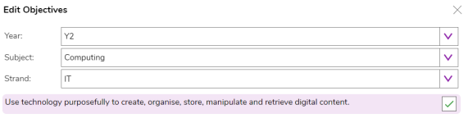  Lesson outline:  Go through Purple Mash lesson 2 slides up to Activity 1.  Activity 1: Display Slide 8. Send the children to their desks and have a go at editing the Twinkle Twinkle tune (this has been set as a 2Do) to make it sound better. Can they make sure the instruments they add compliment the tune rather than change it so much the original tune can’t be heard.  Activity 2: Display Slide 11. The children return to their device and compose a tune to show how they are feeling. Remind the children to regularly save their work in their work folder. Display Slide 12. The children save their music to the class display board.  Plenary: Review vocabulary and definitions.
 | 7  Unit 2.7  Lesson 3  Soundtracks | • To upload a sound from a bank of sounds into the Sounds section.  • To record their own sound and upload it into the Sounds section.  • To create their own tune using the sounds which they have added to the Sounds section | Record your own sound and upload it to the sounds section.  Create your own tune using the sounds you have added to the sounds section. | • Children have uploaded and used their own sound chosen from a bank of sounds.  • Children have created, uploaded and used their own recorded sound.  • Children have created their own tune using some of the chosen sounds. | Preparation:  Set “2Sequence” and “2Beat” as 2Dos.  Lesson outline:  Go through PM slides to Activity 1.  Activity 1: Display slide 9. Send the children to their devices to compose their theme tune for their chosen film or cartoon. Remind the children to save their work.  Display slide 10. Bring the children back together and by using the impersonating user function listen to some of the children’s compositions. Can the children guess what type of cartoon or film they have based their composition on?  Activity 2: Display slide 11. Can the children compose a piece of music using the record feature in 2Sequence? They could use finger clips, mouth ‘pops’ (the peapod sound), cough, sniff, sneeze, tongue click. Can they position them in 2Sequence to make a tune?  Plenary: Review vocabulary and definitions

