Computing Medium Term Planning
Term: Autumn 2 | Year: 5/6 | Topic/Unit: 6.2 Online Safety and 6.6 Networks
Key Vocabulary
Lesson 1 &2- Secure websites, location sharing, spoof, phishing, passwords, PEGI rating, digital footprint, inappropriate
Lesson 3- Screen Time, Data Analysis, Print Screen
Lesson 4- Internet, World Wide Web, Website, Network, Web Server, Web Page, Hosting, Data
Lesson 5- LAN (Local Area Network), WAN (Wide Area Network), WLAN (Wireless Local Area Network), Router, Hub/Switch, Ethernet, Wi-Fi

Lesson 6- Search Engine, IP address, ISP (Internet Service Provider), DNS (Domain Name Server)

National Curriculum | Week | NC Coverage | Skills taught | Knowledge | Activity Outline
- To identify benefits and risks of mobile devices broadcasting the location of the user/device. E.g. apps accessing location.  - To identify secure sites by looking for privacy seals of approval. E.g. https, padlock icon.  - To identify the benefits and risks of giving personal information and device access to different software.  - To review the meaning of a digital footprint and understand how and why people use their information and online presence to create a virtual image of themselves as a user.  - To have a clear idea of appropriate online behaviour and how this can protect themselves and others from possible online dangers, bullying and inappropriate behaviour.  - To begin to understand how information online can persist and give away details of those who share or modify it.  - To understand the importance of balancing game and screen time with other parts of their lives. E.g. explore the reasons why they may be tempted to spend more time playing games or find it difficult to stop playing and the effect this has on their health.  - To identify the positive and negative influences of technology on health and the environment.  - To discover what children know about the internet.  - To find out what a LAN and WAN are.  - To find out how we access the internet in school.  - To research and find out about the age of the internet.  - To think about what the future might hold. | 1 & 2  Unit 6.2 Lessons 1&2  Message in a Game  Online Behaviour | Identify benefits and risks of mobile devices.  Identify secure sites by looking for privacy seals of approval.  Understand the meaning of a digital footprint.  Understand the meaning of appropriate online behaviour. | To review and identify all the safe symbols.  To review and identify the steps needed to protect themselves online.  To identify the consequences of promoting inappropriate content online. | • Children have used the example game and further research to refresh their memories about risks online including sharing location, secure websites, spoof websites, phishing and other email scams.  • Children have used the example game and further research to refresh their memories about the steps they can take to protect themselves including protecting their digital footprint, where to go for help, smart rules and security software. | Preparation:  Lesson 1 - Set 2DIY3D Online Safety Game as a 2Do.  Lesson 2 – Set 2Investigate ‘Applicants Database’ & ‘Digital Footprint writing template’ as a 2Do for the class.  Select the following objectives when setting the 2Do:  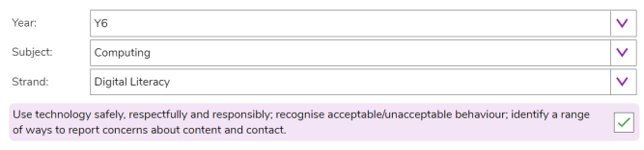  • (Lesson 2) - Print/ copy ‘Digital Footprint Detectives Sheet’ and ‘Screen-Time Record Card’ for each child.  • Optional: If children have not followed these units in previous year groups –  o Digital Footprint Slideshow  o Digital Footprint Quiz o Digital Connections  Lesson 1:  Go through slides 2, 3 and 4 to outline and discuss the lesson aims, success criteria and vocabulary.  Slide 5 (Activity 1 – Online Safety Game): Display slide 5. The children may have come across many terms associated with online safety from previous years. Click the icon to demonstrate the Online Safety Game. Allow children to complete this from their 2Dos.  Slide 6: Review the different symbols.  Slide 7 (Activity 2 – Creating Your Own Game): Use slide 7 to direct the activity. Clicking the icons will open the tools to demonstrate if necessary. If children have followed the scheme in previous years, these tools will be familiar to them. Use the help videos within the tools if needed. Children should save their games to a Purple Mash Display board or a Class Blog  Lesson 2:  Applicants Database: Use slide 6 to direct the activity. Clicking reveals further actions. You will need to hand out the Digital Footprints Detectives sheets.  Use slides 7-8 to help children analyse what they have found out. Clicking reveals further questions and answers.  Writing Frame: Use the writing frame to discuss and record the issues on slides 9-11. Clicking reveals answers to the posed questions. Children could make notes on the writing frame as they go or complete this afterwards. Select which of these topics are relevant to the individual circumstances of your class. For example, you might want to extend this to implications of sending intimate images and sexting if this is something encountered by children in your school.  Plenary:  Review meaning of vocabulary and success criteria.
 | 3  Unit 6.2 Lesson 3  Screen Time | Understand the importance of balancing game and screen time with other parts of their lives.  Identify the positive and negative influences of technology on health and the environment. | To give reasons for limiting screen time.  To identify positive and negative aspects of technology.  To find a balance between being active and digital activities, | • Children can take more informed ownership of the way that they choose to use their free time. They recognise a need to find a balance between being active and digital activities.  • Children can give reasons for limiting screen time.  • Children can talk about the positives and negative aspects of technology and balance these opposing views.  • Extension: Children have an internalised in-depth understanding of the risks and benefits of an online presence. | Preparation:  • Screen-Time 2Investigate Database. You should save this in the shared class folder in Purple Mash but do not set the database to be collaborative yet.  • Screen Time Study writing frame to be set as a 2Do.  • Improving Lives with Technology; This writing frame can be found in Computing > Writing Projects. Some children might choose to research this area for Activity 4 and use this alternative writing frame. It could be set as a 2Do if you wish to use it.  You can select the following computing objectives when setting the 2Dos to make future assessment easier:  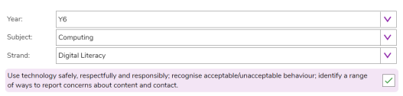  Lesson outline:  Discuss new vocabulary and success criteria with the children on slides.  Activity 1: Use slide 6, you might have to show children how to calculate average hours of sleep per night. The slide asks children to consider their personal screen-time, privately. Stress that this is not an exercise in embarrassing anyone or a competition  Use slide 7-8 and follow the instructions to make the database collaborative.  Activity 2: Use slide 9 to guide children with entering the data.  Activity 3: Use slide 10 to Show the children how to select table view and discuss any trends or patterns they can see in this format. Demonstrate using the search facility to create queries, let the children attempt too. Use slides 11-13 Guide children in creating and saving graphs and then analysing what they show. Test the different fields and what they look like when represented in a graph. Some fields will be better suited in 2Graph. You could print the data in table view and get the children to create in 2Graph. On slide 14 -15, your discussion about upsetting content will depend upon children’s experiences. The important teaching point is to give children the knowledge of what to do in this situation.  Activity 4: Use slide 16 to open a link to the writing frame or the alternative noted in the ‘Resources’ section. Children should write about the class discussion and their opinions and strategies. They could consider various aspects or concentrate on just one, doing further research into the area themselves. If they completed this lesson in year 4, then it would be better for children to research one area in more depth with different children allocated different areas. They should then share their results on a class blog or display board. Explain how to upload the graph image if necessary.  Plenary:  Review meaning of vocabulary (click on words to reveal the definitions)
 | 4  Unit 6.6  Lesson 1  The World Wide Web and the Internet | To discover what the children know about the internet. | To know the difference between the World Wide Web and the Internet. | • Children know the difference between the World Wide Web and the Internet.  • Children can provide examples of the difference between the World Wide Web and the Internet. | Preparation:  PLEASE NOTE: Lesson 1 requires children to have completed a questionnaire prior to the lesson. Use this link for the questionnaire so you can ask children to do this in advance. Communication Questionnaire  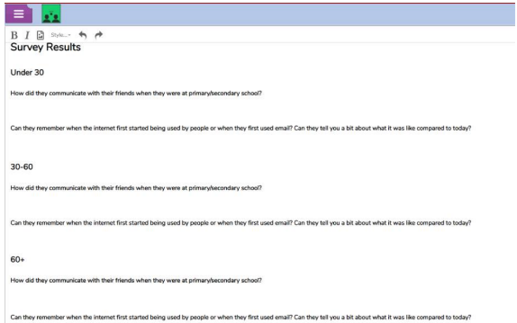  • Create a collaborative 2Write file called ‘Survey Results’ and save this in a shared class folder. Set it up to reflect the survey, split into different age groups like this example  • Purple Mash 2Connect tool. This is accessed by going to Tools>Communicating and Sharing>2Connect. It could be set as a 2Do for children. You can select the following objectives when setting the 2Dos to make future assessment easier:  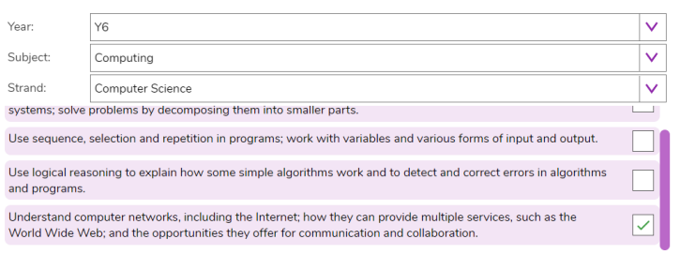  Lesson outline:  Go through PM slides.  Activity 1: Use slide 5 to direct children to the activity. Responses should appear real time on the 2Write file, this could be displayed on the whiteboard whilst children work. Responses will be reviewed later in the lesson.  Activity 2: Use slide 6 to direct the activity. If children have been following the Computing scheme of work, they will have used 2Connect in the past. If they have not, it might be useful to watch the help videos within the tool to provide a quick overview. These can be accessed from within 2Connect using the button on the top right.  Questionnaire Reflections: Use slide 7, discussion will depend upon the responses collected.  Video: Click on the image to open the BBC Bitesize page and watch the video.  Plenary:  Reflect on what was in the video.
 | 5  Unit 6.6  Lesson 2  Our School Network and Accessing the Internet | Find out what a LAN and WAN are.  Find out how we access the internet in school. | To know about their school network.  Explain the differences between more than two network types. | • Children know about their school network.  • Children can explain the differences between more than two network types such as: LAN, WAN, WLAN and SAN. | Preparation:  • It would be useful to have your school technician come into the classroom and talk to the children about the school network. • A router, network cables, modem.  • Resources within the school network  • 2Connect or 2Chart tool  Lesson outline:  Go through PM slides. Introduce vocabulary.  Devices in the Classroom and in the School: Use slide 5 to guide an exploration of the classroom. Use slide 6 to start thinking about a network in school and what this means.  Network components: Take the children through the devices that are part of a local area network using slides 7 – 11. If you have examples, show them to the children.  Activity 1: Technician Talk and Learning Walk  Slide 12 - If you have a technician available to talk to the children about the school network and to answer their questions this would be useful. The children could go on a learning walk with the technician around the school to answer the questions in this lesson. Ensure that the technician has a copy of the questions  Activity 2: Diagram  Upon returning to the classroom, use slide 13 to direct children in a task. They can choose to use either tool to do this. This could be done individually or as a whole class task. Clicking shows some examples.  Wide Area networks: Use slides 14-15 to consider networks covering more than one geographical site.  Activity 3: Extension  Slide 16 contains extension tasks that children might need to research for. Slide 17 contains some possible solutions  Plenary:  Review the success criteria and vocabulary taught from the lesson.
 | 6 & 7  Unit 6.6 Lesson 3  Research | To research and find out about the age of the internet.  To think about what the future might hold. | Research and find information about Tim Berners-Lee.  Identify major changes in technology. | •Children have researched and found out about Tim Berners-Lee.  • Children have considered some of the major changes in technology which have taken place during their lifetime and the lifetime of their teacher/another adult. | Preparation:  Set the activity Sir Tim Berners-Lee Profile as a 2Do for the class. You can select the following objectives when setting the 2Dos to make future assessment easier:  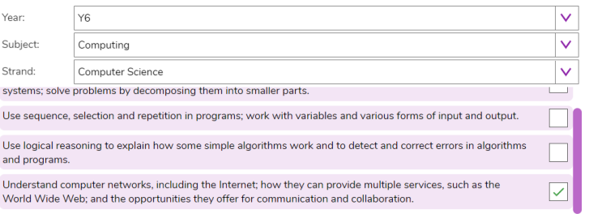  Lesson outline:  Go through PM slides, introduce vocab etc.  Activity 1: Concept map.  Use slide 6 to introduce this activity. The link is clickable, this could be done using a collaborative 2Connect file. See the 2Connect user guide for more information. Slide 7 contains an example concept map  Activity 2: Sir Tim Berners-Lee  Use slides 8 – 9 to introduce the activity. Clicking reveals answers and information.  Changes In Your Lifetime  Use slides 10-11 to help children think about the changes in technology that they have seen so far in their lifetime. Clicking reveals some images to help children remember. Talk to the children about the changes in technology that you have seen as an adult.  Plenary: Review success criteria and lesson vocabulary.

