Geography. Medium Term Planning
Term: Autumn | Year: EYFS | Theme: Traditional tales and Celebrations
Key vocabulary- See vocabulary progression EYFS

National Curriculum | Week | NC- Coverage | Activity Outline
Understanding the world.  3 and 4 year old- Nursery  • Plant seeds and care for growing plants.  • Understand the key features of the life cycle of a plant and an animal.  • Begin to understand the need to respect and care for the natural environment and all living things  Reception  • Recognise some similarities and differences between life in this country and life in other countries. • Explore the natural world around them.  • Describe what they see, hear and feel whilst outside.  • Recognise some environments that are different to the one in which they live.  • Understand the effect of changing seasons on the natural world around them  ELG- the natural world  • Explore the natural world around them, making observations and drawing pictures of animals and plants.  • Know some similarities and differences between the natural world around them and contrasting environments, drawing on their experiences and what has been read in class.  • Understand some important processes and changes in the natural world around them, including the seasons and changing states of matte | 1 | Reception  • Recognise some similarities and differences between life in this country and life in other countries.  • Know some similarities and differences between the natural world around them and contrasting environments, drawing on their experiences and what has been read in class. | Children will explore the settings of 'The Gruffalo' and 'Goldilocks and the Three Bears', identifying and bringing forward characteristics of the forest and a home, respectively. Pupils will use descriptive words and discuss various geographical features of each setting.  Talk about human and physical features. Explain that in Goldilocks, the forest is physical and the house is human.
 | 2 | • Know some similarities and differences between the natural world around them and contrasting environments, drawing on their experiences and what has been read in class. | Using 'Jack and the Beanstalk' and 'The Little Red Hen', children will create simple maps to chart the journeys taken by characters. They will draw paths and mark locations mentioned in the stories, discussing how characters move from one place to another.  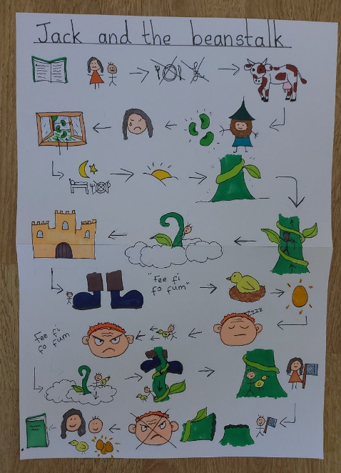
 | 3 | Reception  • Recognise some similarities and differences between life in this country and life in other countries. | Children to identify what part of the world that different celebrations happen. Discuss the cultural differences.

