Lesson | Activity Outline | Knowledge and Skills | Context
1 | Objective: To understand what it means to eat healthily.  Book Link: Which Food Will You Choose – Claire Potter  This lesson is following Kapow: EYFS (Reception) > Managing self: My wellbeing > Lesson 5: Eating healthily  Before the lesson have ready feely bags (one per group); dried pasta (one piece per bag).; apples.; broccoli.; potatoes; bananas; bread rolls and oranges)  1. Sit the children in a circle and ask each child to share their favourite food. Discuss the similarities and differences between the children’s answers.  2. Talk about the fact that it is important to eat a balanced diet – this means eating lots of different types of foods that all play a different part in keeping our body healthy. Explain that some foods are good for our teeth, some give us long-lasting energy, some give us quick bursts of energy, some keep our tummies full and some help our brains to develop.  3. Divide the class into small groups (if more resources are available, pupils can work in pairs).  4. Hand each group a feely bag filled with some of the food (pasta, an apple, broccoli, a potato, a banana, an orange and a bread roll). Bags do not have to contain the same items.  5. Ask the children to take turns putting their hands inside the bag and feeling one of the pieces of food. They must use their senses (without looking) to guess what the food is. When they have made a guess, they can pull it out to see if they are right. Repeat until all the food has been identified.  6. Bring the group back together and look at the food that each group was given. Highlight some of the foods and explain why they are important (see Teacher notes for guidance).  7. Discuss that it is ok to be unsure about food the first time they try it – it usually takes several tries before getting used to a new food. The most important thing is to try new foods. The more they try them, the more likely they will enjoy them!  Floorbook expectation: pupil voice from the main event, images and QR codes. | Knowledge:  Children at the expected level of development will:  Manage their own basic hygiene and personal needs, including dressing, going to the toilet and understanding the importance of healthy food choices.  Skills:  Children in reception will be learning to:  Know and talk about the different factors that support their overall health and well-being:  healthy eating. | Walsall Child Health Profile  These charts show the percentage of children classified as obese or overweight in Reception (aged 4-5 years)  and Year 6 (aged 10-11 years) by local authority compared with their statistical neighbours. Compared with the  England average, this area has a worse percentage in Reception and a worse percentage in Year 6 classified  as obese or overweight.  Children aged 4-5 years classified as obese or overweight, 2014/15 (percentage)  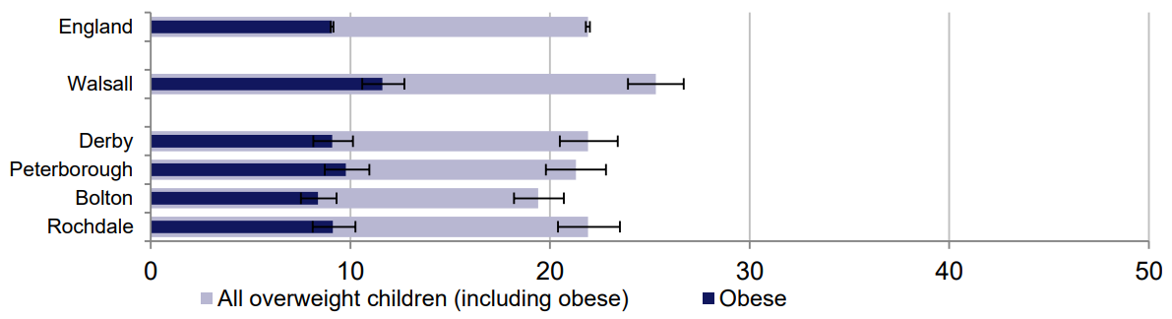  Children aged 10-11 years classified as obese or overweight, 2014/15 (percentage)  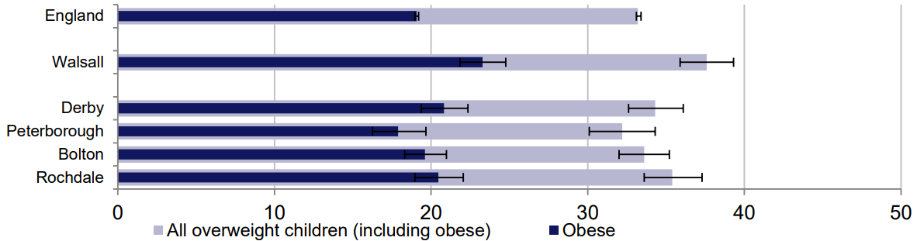
2 | Objective: To understand the importance of healthy food choices.  Book Link: I Can Eat A Rainbow by Olena Rose  This lesson is following Kapow: EYFS (Reception) > Managing self: My wellbeing > Lesson 6: A rainbow of food  1. While sitting at tables or with clipboards, assign each child two pieces of food from the Resource: Rainbow food list (it doesn’t matter if some have the same food as others). Ask pupils to draw a picture of the food and colour it in the correct colour. If they are unsure what the food looks like, show them visual examples below.  2. Encourage the children to use their phonic knowledge to write a name label under each picture. Ask them to cut out each picture (with the picture and label cut out as one) and bring them to the carpet.  3. Show them the rainbow you have created (see Teacher notes) and ask the children to sort their foods into the correct colour, pointing out the additional white/brown section.  4. Look at the rainbow as a group and discuss the various colours within the foods. Talk about the importance of eating a colourful diet – the more colourful their meal, the better. Explain to the children that eating lots of colours is one way to ensure they eat a varied and balanced diet.  5. Task the children with counting the colours in their next meal. If there aren’t many, ask them to think about which foods they could introduce to solve the problem (more vegetables or a piece of fruit will usually do the trick).  Floorbook expectation: pupil voice from the main event, images and QR codes. | Knowledge:  Children at the expected level of development will:  Manage their own basic hygiene and personal needs, including dressing, going to the toilet and understanding the importance of healthy food choices.  Skills:  Children in reception will be learning to:  Know and talk about the different factors that support their overall health and well-being:  healthy eating. | A large amount of our children are FSM, where they may not be able to explore a variety of food types at home, providing that opportunity in school is vital.  Walsall Public Health Report:  